
Cartly Project Documentation
Full project documentation

October 23, 2026
Code alpha
Lucknow, India

🛒 Cartly
Project Documentation
1. Executive Summary 3
2. Introduction 3
2.1 Problem Statement 3
2.2 Project Objectives 3
2.3 System Boundaries (Scope) 4
2.4 Stakeholder Analysis 4
2.5 Administrative Control Scope 4
3. Scenario Writing 5
Scenario-1: User Registration / Login / Logout 5
Scenario-2: Product Catalogue / Search / Filtering 5
Scenario-3: Product Detail / Ratings / Related Products 5
Scenario-4: Cart Add / Update / Remove 5
Scenario-5: Checkout and Cash-on-Delivery Order 5
Scenario-6: Order History / Order Detail 5
Scenario-7: Wishlist Add / Remove / View 6
Scenario-8: Customer Review Submission / Update 6
Scenario-9: Staff Review Moderation 6
Scenario-10: Profile Viewing / Editing 6
Scenario-11: Staff Product / Inventory Management 6
Scenario-12: Staff Order Status Management 6
4. Requirement Specification 7
4.1 Functional Requirements (FR) 7
4.2 Non-Functional Requirements (NFR) 8
5. System Design & Architecture 8
5.1 System Architecture Diagram 8
5.1.1 Staff Control and Administration Architecture 9
5.2 System Modeling 9
Use Case Diagram 9
Staff / Administrator Use Case Diagram 10
Activity Diagrams 11
Scenario-1: User Registration / Login / Logout 11
Scenario-2: Product Catalogue / Search / Filtering 12
Scenario-3: Product Detail / Ratings / Related Products 13
Scenario-4: Cart Add / Update / Remove 14
Scenario-5: Checkout and Cash-on-Delivery Order 15
Scenario-6: Order History / Order Detail 16
Scenario-7: Wishlist Add / Remove / View 17
Scenario-8: Customer Review Submission / Update 18
Scenario-9: Staff Review Moderation 19
Scenario-10: Profile Viewing / Editing 20
Scenario-11: Staff Product / Inventory Management 21
Scenario-12: Staff Order Status Management 22
5.3 Database Design 23
UML Class Diagram (Entity Relationships) 23
Data Dictionary 23
User Table (Django Authentication Model) 23
Product Table 24
Order Table 24
OrderItem Table 25
WishlistItem Table 25
Review Table 25
Django Session Cart (Runtime State) 26
Database Integrity Rules 26
6. Technical Implementation 27
6.1 Backend / Data Interaction Documentation 27
6.1.1 Backend Organization 27
6.1.2 RESTful API Endpoints 27
Catalogue Query Parameters 28
API Behavior Notes 28
6.1.3 Product Image Handling Rules 28
6.1.4 Catalogue Search and Filtering 28
6.1.5 Cart and Checkout Transaction Rules 29
6.1.6 Staff Control and Review Moderation 29
6.2 Relationship & Access Rules 29
6.3 Frontend Organization 29
6.4 Administration Frontend Organization 30
7. Quality Assurance & Testing 30
7.1 Test Case Scenarios 30
7.1 Test Case Scenarios (Continued) 31
7.2 Requirements Traceability Matrix (RTM) 32
8. Individual Contribution 32
Technical Challenges 33
Learning Outcomes 33
9. Conclusion & Future Work 33
9.1 Conclusion 33
9.2 Future Enhancements (Version 2.0) 33
10. Appendices 34
Appendix A: Project Repository and Source Review 34
Appendix B: Backend Setup 34
Appendix C: Frontend Setup 35
Appendix D: API, CSRF, Media and Cart Assumptions 35
Appendix E: Administrator Setup and Responsibilities 35
Appendix F: References and Verification Notes 36

1. Executive Summary
Cartly is a full-stack e-commerce storefront that allows customers to discover products, manage a shopping cart, place Cash on Delivery (COD) orders, save items to a personal wishlist, and submit product reviews. The current repository uses a static HTML, CSS and vanilla JavaScript frontend that communicates with a Django REST Framework JSON API. PostgreSQL stores persistent product, customer, order, wishlist and review records. Django session authentication and CSRF validation are used for authenticated state-changing requests.
The system is intentionally focused on a coherent shopping journey rather than a large marketplace feature set. Product catalogue data is managed by staff through Django Admin; the customer-facing storefront obtains current values from the backend. Cart contents are held in the Django session and do not treat browser-supplied prices as authoritative. At checkout, the backend rechecks availability, locks product rows in a transaction, creates the order and order items, records the purchase-time product name and price, reduces stock, and clears the session cart after successful commit.
Main Value Proposition:
- For Customers: discover and filter products, inspect product details and approved reviews, save products, manage a session cart, place COD orders, and view their own order history.
- For Store Staff: maintain product details and inventory, inspect orders and update order statuses, manage customer accounts, and moderate product reviews using Django Admin.
- For Software Engineering: demonstrate requirements analysis, a modular Django application structure, a relational data model, a session-authenticated API, server-side business rules, transaction safety, CSRF protection, media handling, and automated testing.
Technology Stack:
- Frontend: HTML5, CSS3, vanilla JavaScript using native ES modules, Fetch API, and responsive CSS.
- Backend: Python, Django 5.2, Django REST Framework, django-cors-headers and python-dotenv.
- Database: PostgreSQL accessed through psycopg.
- Media: Django ImageField and local media storage during development; production storage and serving require deployment configuration.
- Development and Verification: Git, GitHub, VS Code, Django management commands and Django REST Framework test clients.
Repository verification note: this documentation is based on the current public repository README and source files inspected for the product, order, wishlist and review models, API views, serializers, account forms, cart service, settings, routing, frontend entry point and existing tests. The application and database were not executed as part of preparing this document, so test execution results are not claimed.

2. Introduction

2.1 Problem Statement
A basic online store needs more than a product list. Customers must be able to make a choice, retain items while browsing, supply delivery details, receive a trustworthy order result, and revisit past purchases. The store must also keep inventory correct when more than one customer is shopping, prevent customers from reading each other’s order data, and avoid displaying unreviewed content as public feedback. Cartly connects these user-facing activities to one backend and database so that pricing, permissions and order completion are decided by the server.

2.2 Project Objectives
- Provide customer registration, email-based sign-in, sign-out and profile editing using Django sessions.
- Present a catalogue of active products with name/description/category search, category filters, price range, stock filters, sorting and pagination.
- Show product details, image availability, related items, stock status, and ratings calculated from approved reviews only.
- Maintain a session-based cart using product identifiers and quantities; calculate displayed line totals from current database prices.
- Place COD orders through a validated checkout, rechecking stock and writing order and order-item records within a database transaction.
- Preserve each purchase-time product name and price in the order item so later catalogue edits do not rewrite the historical order line.
- Allow signed-in customers to save/remove products in a private wishlist and submit/update one review per product.
- Keep new or edited reviews hidden until staff approval and allow staff to manage the catalogue, orders, customers and review visibility through Django Admin.
- Separate frontend presentation, API communication, business logic and relational persistence to support maintainability and testability.

2.3 System Boundaries (Scope)
- In Scope: public product discovery; search/filter/sort/pagination; product detail and related products; account registration/login/logout/profile; session cart; stock-aware COD checkout; order history and detail; wishlist; review creation/update and staff approval; product and inventory management; Django Admin order-status actions; CSRF/session security; local product media; automated tests present in the repository.
- Out of Scope / Not Present in the Current Repository Contract: online card or wallet payments, multi-vendor seller accounts, shipping carrier integrations, discount/coupon engine, customer-to-customer messaging, product recommendations beyond simple popular/new collections, a separate custom administration dashboard, email/order notifications, and analytics beyond standard Django Admin listings.

2.4 Stakeholder Analysis
- Visitor: browses public active products and can maintain a cart through the browser session; must register/sign in for personal wishlist features, profile edits, reviews, checkout and order history.
- Registered Customer: expects current product and stock information, clear form validation, private wishlist/order data, reliable COD checkout, and transparent review moderation.
- Store Staff / Administrator: requires permissions to manage products and stock, search orders, change order status, inspect accounts and approve/hide reviews.
- Project Evaluator / Developer: needs a traceable implementation of requirements, API contracts, relational modeling, security rules, test coverage and setup instructions.

2.5 Administrative Control Scope
Cartly uses Django Admin at `/admin/` rather than a separate custom staff dashboard. Product administration includes searchable/filterable product records and editable price, stock and active status. Order administration includes search, filters, line-item inspection, read-only timestamps and bulk status actions. Review administration includes approval filters, search, list editing and “Approve selected reviews” / “Hide selected reviews” actions. Django authentication and model permissions are the access-control layer; merely hiding an administration link in the frontend is not a security control.

3. Scenario Writing

Scenario-1: User Registration / Login / Logout
Request Entry: Visitor opens the storefront account overlay and chooses registration or login.
Input Data: Registration accepts full name, email, password and confirmation. Username is generated from the email prefix when not supplied. Login accepts email and password.
Validation: Django forms validate required fields, password rules, duplicate email checks and authentication credentials. State-changing requests require a CSRF token.
Success: Registration signs the new user in; login starts a session; logout clears the session and returns the visitor to the storefront.

Scenario-2: Product Catalogue / Search / Filtering
Request: Customer opens the catalogue or submits a search/filter form.
Query: Backend begins with active products and optionally applies q, one or more category values, min/max price, stock=1, sort and page parameters.
Ordering / Pagination: Newest, ascending price, descending price or rating ordering is applied; results are paginated at nine items per page.
Display: Frontend shows products and filters while preserving query parameters. Empty matches must produce a useful empty state.

Scenario-3: Product Detail / Ratings / Related Products
Selection: Customer opens a product by its unique slug.
Availability: Backend returns only an active matching product; inactive or missing products return a not-found state.
Related Content: Up to four active products from the same text category may be offered as related items.
Ratings: Average rating and review count are aggregated from approved reviews only. Signed-in users can see their own review state.

Scenario-4: Cart Add / Update / Remove
Action: Customer adds a product, changes quantity or removes it from the cart.
Storage: Cart service stores product IDs and quantities in the Django session, not a separate cart table.
Validation: API validates positive quantities and compares them with current stock; updates can set quantity to zero to remove an item.
Response: Returned cart payload resolves live products/prices from the database, calculates line totals, reports item count and flags unavailable quantities.

Scenario-5: Checkout and Cash-on-Delivery Order
Authentication: Checkout and order creation require a signed-in customer; empty carts are rejected.
Delivery Input: Checkout validates full name, email, phone, address, city and optional postal code. COD is currently the only payment method.
Transaction: Backend opens a database transaction and locks each active product row before validating current stock.
Commit: Order and OrderItem records are created using server prices and purchase-time names, product stock is reduced and order total is computed from database values. The cart is cleared after a successful transaction.

Scenario-6: Order History / Order Detail
Access: Signed-in customer opens the order list or selects one order.
Filtering: Order list is filtered by the current user. Detail lookup checks both order ID and owner.
Display: Order shows delivery information, payment method, status, total, item quantity, historical product name and price.
Privacy: A different customer cannot retrieve the order; the API returns not found instead of disclosing another customer’s record.

Scenario-7: Wishlist Add / Remove / View
Access: Customer uses a wishlist control or opens the personal wishlist page.
Authentication: Wishlist APIs require an authenticated user.
Persistence: Adding uses get_or_create and a unique user/product constraint; deleting scopes the operation to the current user.
Result: The product serializer exposes `in_wishlist` for the signed-in customer. Only the current user’s saved products are returned.

Scenario-8: Customer Review Submission / Update
Read: Public product pages list approved reviews and show an average and count based on approved records.
Input: Signed-in customer selects a rating from one to five, an optional title and review text.
Uniqueness: One review record is allowed for each user/product pair. If that pair exists, a submission updates the existing review rather than creating a second one.
Moderation State: Every create or update sets approval to false; the customer receives a response while the review remains hidden from public lists until staff approval.

Scenario-9: Staff Review Moderation
Access: Authorized staff opens the Review model in Django Admin.
Inspection: Staff searches/filters by product, customer, rating, date or approval state.
Decision: Staff approves or hides selected reviews using admin actions or the editable approval field.
Effect: Only approved reviews contribute to public rating aggregates and lists; a later edit by the customer returns that review to pending state.

Scenario-10: Profile Viewing / Editing
Access: Customer opens profile. Profile endpoints require authentication.
Fields: Profile form uses the current Django User first name, last name and email.
Validation: The form checks whether the email is already used by a different user, using case-insensitive application validation.
Save: The current user record is updated; the page can show order and wishlist counts. No separate profile database model is used.

Scenario-11: Staff Product / Inventory Management
Access: Staff with the relevant model permission opens Products in Django Admin.
Maintenance: Staff creates or updates name, description, price, stock, category text, image and active status.
Rules: Price has a non-negative validator; stock is a positive integer field with zero allowed; a unique slug is generated if absent.
Publication: Only active products are returned by the customer-facing catalogue and detail endpoint. In-development images are stored under the media product path.

Scenario-12: Staff Order Status Management
Access: Staff opens Orders in Django Admin and searches/filters records.
Inspection: Order items are shown inline; order total, status, payment method and creation time are visible.
Action: Bulk actions support confirmed, processing, shipped, delivered and cancelled status values.
Result: The stored status is returned through the order API and appears in the customer order history/detail. COD payment state does not imply online payment processing.

4. Requirement Specification

4.1 Functional Requirements (FR)
ID | Feature | Description | Stakeholders
FR01 | User Registration | Register with full name, unique application-level email, and Django password validation. | Visitors, Developers
FR02 | Login / Logout | Authenticate by email/password using Django session cookies; clear the session on logout. | Customers
FR03 | Customer Profile | View/edit current user first name, last name and email with ownership enforced server-side. | Customers
FR04 | Home Collections | Return featured, popular, new products and category counts from active database products. | Visitors, Customers
FR05 | Product Catalogue | List active products and search name, description or category. | Visitors, Customers
FR06 | Filtering / Sorting | Support categories, minimum/maximum price, in-stock filter and newest/price/rating sorting. | Visitors, Customers
FR07 | Pagination | Paginate catalogue results at nine products per page and preserve user query context. | Visitors, Customers
FR08 | Product Detail | Show active product data, media URL, stock, related products and approved rating aggregates. | Visitors, Customers
FR09 | Session Cart | Add, update and remove products stored as product IDs and quantities in the Django session. | Visitors, Customers
FR10 | Cart Stock Validation | Reject quantities exceeding current inventory and flag products that have become unavailable. | Visitors, Customers
FR11 | COD Checkout | Accept validated delivery data and create COD orders only for authenticated customers. | Customers
FR12 | Transactional Order Creation | Recheck stock under row locks, write order and line-item records, calculate totals server-side, and reduce inventory atomically. | Customers, Developers
FR13 | Order History / Detail | List orders for the current user and allow detail retrieval only for the owning customer. | Customers
FR14 | Wishlist | Add, list and remove saved products for the authenticated customer only. | Customers
FR15 | Wishlist Uniqueness | Prevent duplicate saved entries for the same customer/product pair. | Customers, Developers
FR16 | Review Submission / Update | Accept a one-to-five rating, optional title and review body; update the existing user/product review if present. | Customers
FR17 | Review Approval | Keep new or edited reviews unapproved until staff moderation. | Staff, Customers
FR18 | Public Rating Aggregates | Expose only approved review content, average rating and review count publicly. | Visitors, Customers
FR19 | Product Administration | Manage product fields, price, category text, image, stock, slug and active state through Django Admin. | Staff
FR20 | Order Administration | Inspect orders and order items; apply supported status actions in Django Admin. | Staff
FR21 | Review / Customer Administration | Manage review visibility, accounts/groups and wishlist records through authorized Django Admin pages. | Staff
FR22 | Session / CSRF API | Expose a CSRF-token endpoint and apply Django session authentication / CSRF checks to state-changing API actions. | All roles, Developers
FR23 | Product Image Handling | Store image file references and return an image URL only when the stored file exists. | Staff, Customers
FR24 | API Error Handling | Return validation/authentication/not-found responses and friendly frontend states without exposing stack traces. | All roles, Developers

4.2 Non-Functional Requirements (NFR)
- Security: Django password hashing and session authentication; CSRF checks on state-changing requests; user-scoped order and wishlist queries; server-side permissions for Django Admin; explicit production SECRET_KEY and ALLOWED_HOSTS.
- Data Integrity: unique slug for products; unique user/product wishlist and review pairs; validated quantity and non-negative price; transaction and row locking for checkout; PROTECT and CASCADE rules for order relationships as defined by models.
- Usability: predictable navigation, responsive layouts, labeled forms, clear validation messages, visible product stock, a clear COD-only payment explanation and empty/error states.
- Performance: catalogue pagination, database filtering/ordering, selective related-object loading and indexed product active/category/name fields; heavier catalog/search needs should be measured before adding optimization.
- Maintainability: domain apps split into accounts, API, cart, orders, products, reviews and wishlists; frontend CSS and JavaScript grouped by base/layout/components/pages/responsive and API/components/pages modules.
- Compatibility: responsive HTML/CSS and native ES module JavaScript in modern browsers; no frontend framework or Node.js build step is required.
- Privacy: profile, wishlist and order endpoints must return data for the current account only; reviews expose only approved content to the public.
- Operational Readiness: local environment variables, database migrations, media/static configuration, HTTPS and secure cookies must be configured appropriately before production deployment.
- Testability: repository Django tests cover important API, CSRF, catalog, cart, wishlist and checkout behaviors; tests should be run against a configured PostgreSQL test database before release.

5. System Design & Architecture

5.1 System Architecture Diagram
Cartly follows a client/API/database architecture. Static storefront files load in the browser and use native JavaScript modules to call the versioned JSON API. Django REST Framework resolves requests, applies authentication/permission and CSRF controls, calls domain application services and uses the Django ORM for PostgreSQL persistence. The session cart stores product identifiers and quantities in session data. Product image files are stored through Django media storage during development.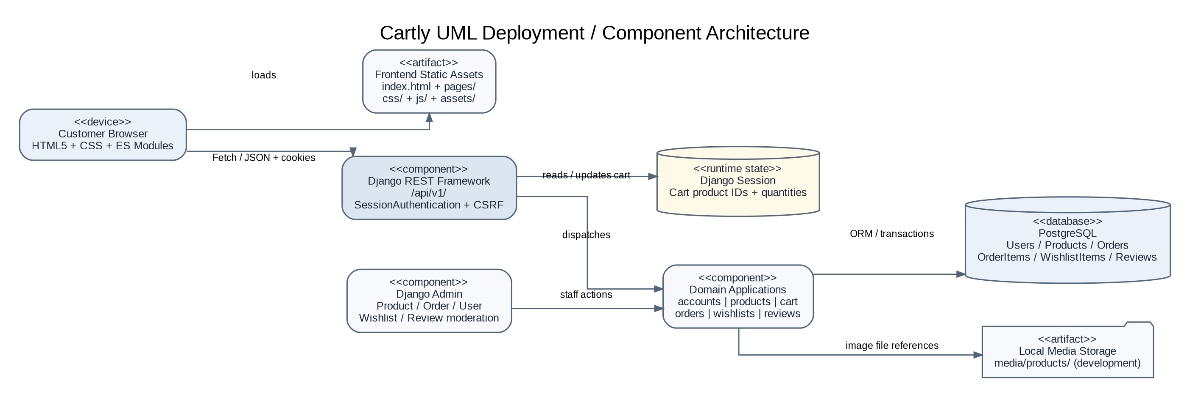
Figure 5.1: Cartly UML Deployment / Component Architecture

5.1.1 Staff Control and Administration Architecture
Store staff access Django Admin rather than a separate API-based dashboard. Model-level permissions gate the admin operations; staff screens manage persistent domain records. Review approval and order status actions are application-level controls. User-facing API endpoints do not expose a general-purpose staff dashboard or admin reporting API in the inspected route list.
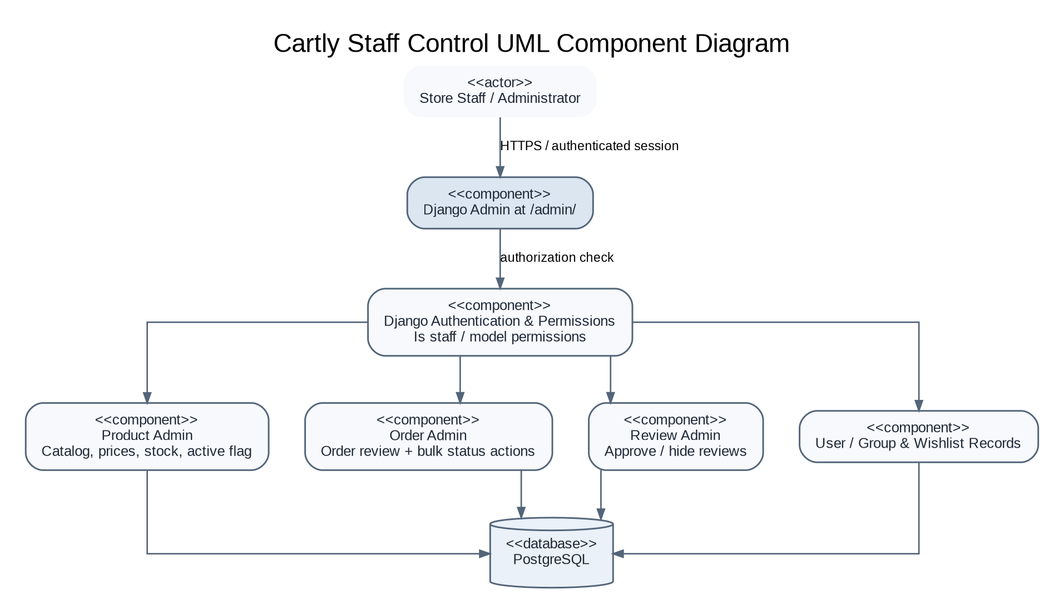
Figure 5.1.1: Cartly Staff Control UML Component Diagram

5.2 System Modeling

Use Case Diagram
The storefront has a public visitor role and an authenticated customer role. Some functions, such as browsing and viewing approved reviews, are available without a session. Account management, wishlist, review submission, checkout and order history require a signed-in customer.
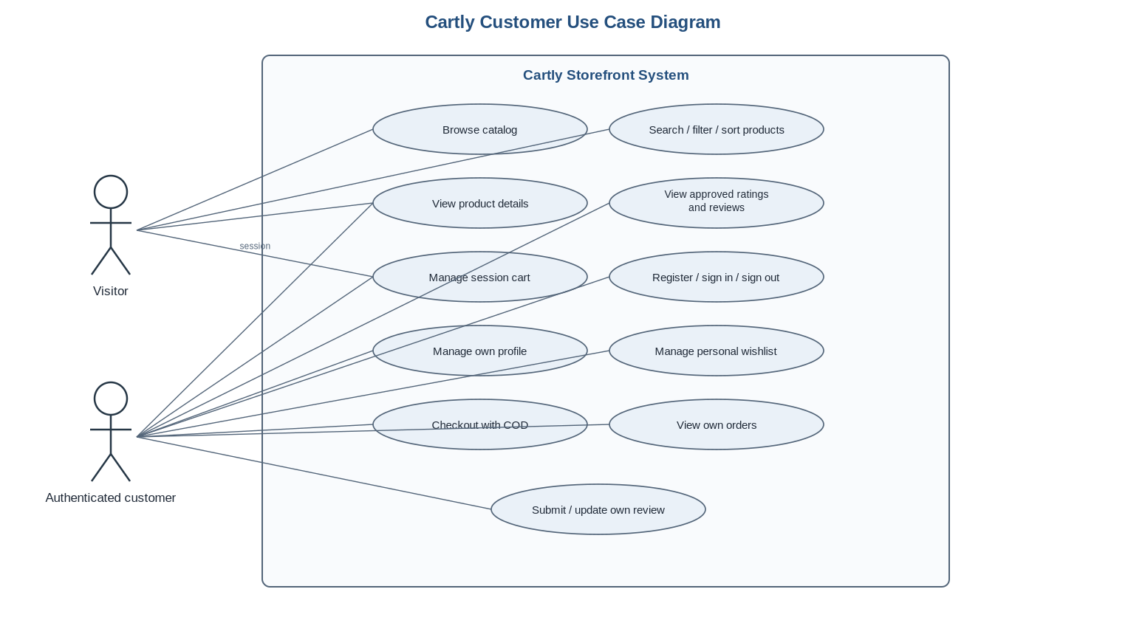
Figure 5.2: Cartly Customer Use Case Diagram

Staff / Administrator Use Case Diagram
Staff use Django Admin with the permissions granted to their account. Administrative capabilities listed below correspond to the Product, Order, Review and standard User/Group administration exposed by Django Admin. 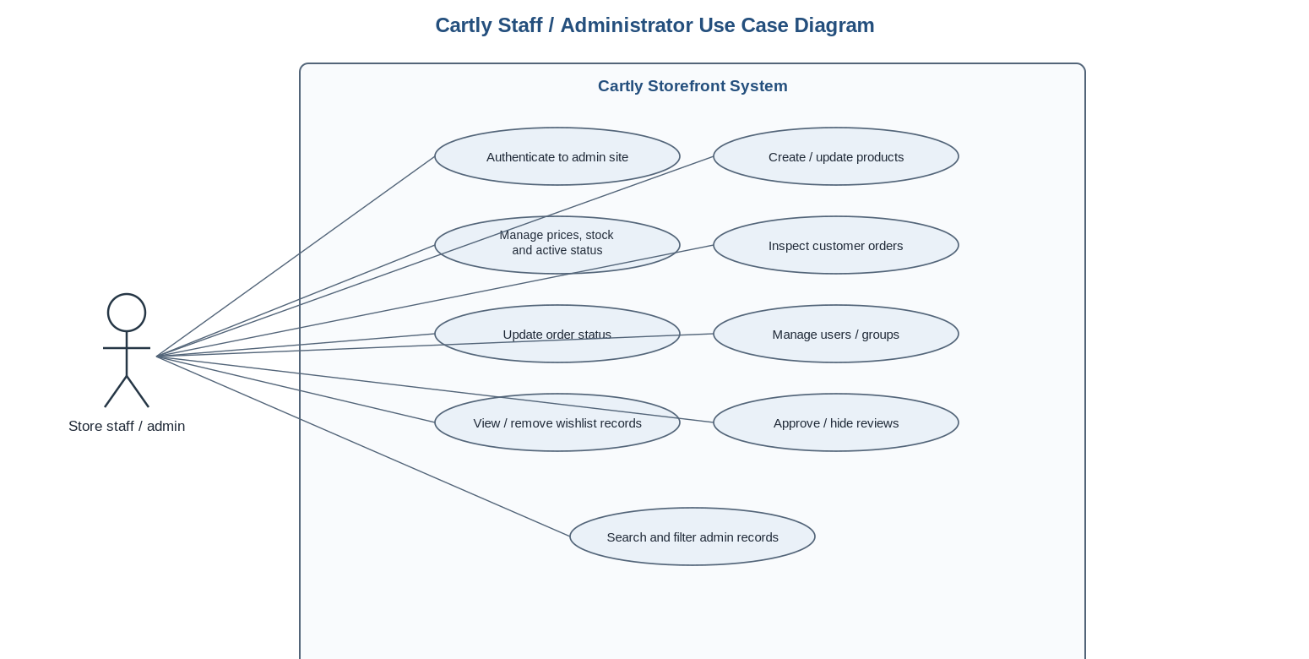
Figure 5.2.1: Cartly Staff / Administrator Use Case Diagram

Activity Diagrams
The following activity diagrams formalize the customer and staff workflows that are directly supported by the current application. They use UML activity notation: initial/final nodes, actions, decision nodes and labeled control-flow edges.

Scenario-1: User Registration / Login / Logout
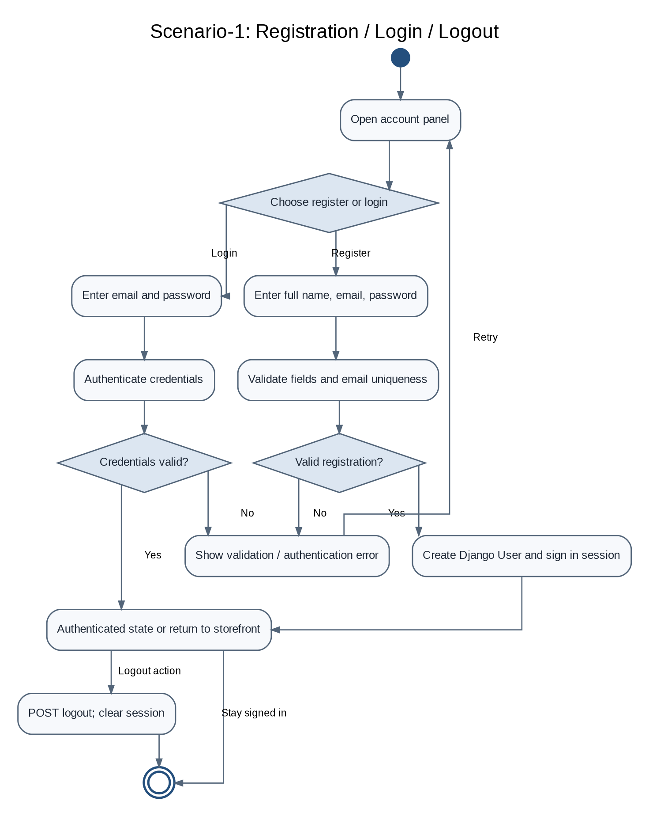
Figure 5.2.2: Scenario-1: User Registration / Login / Logout
The registration form validates required identity and password fields; a successful API registration creates the Django user and establishes the session. Login and logout are session operations.

Scenario-2: Product Catalogue / Search / Filtering
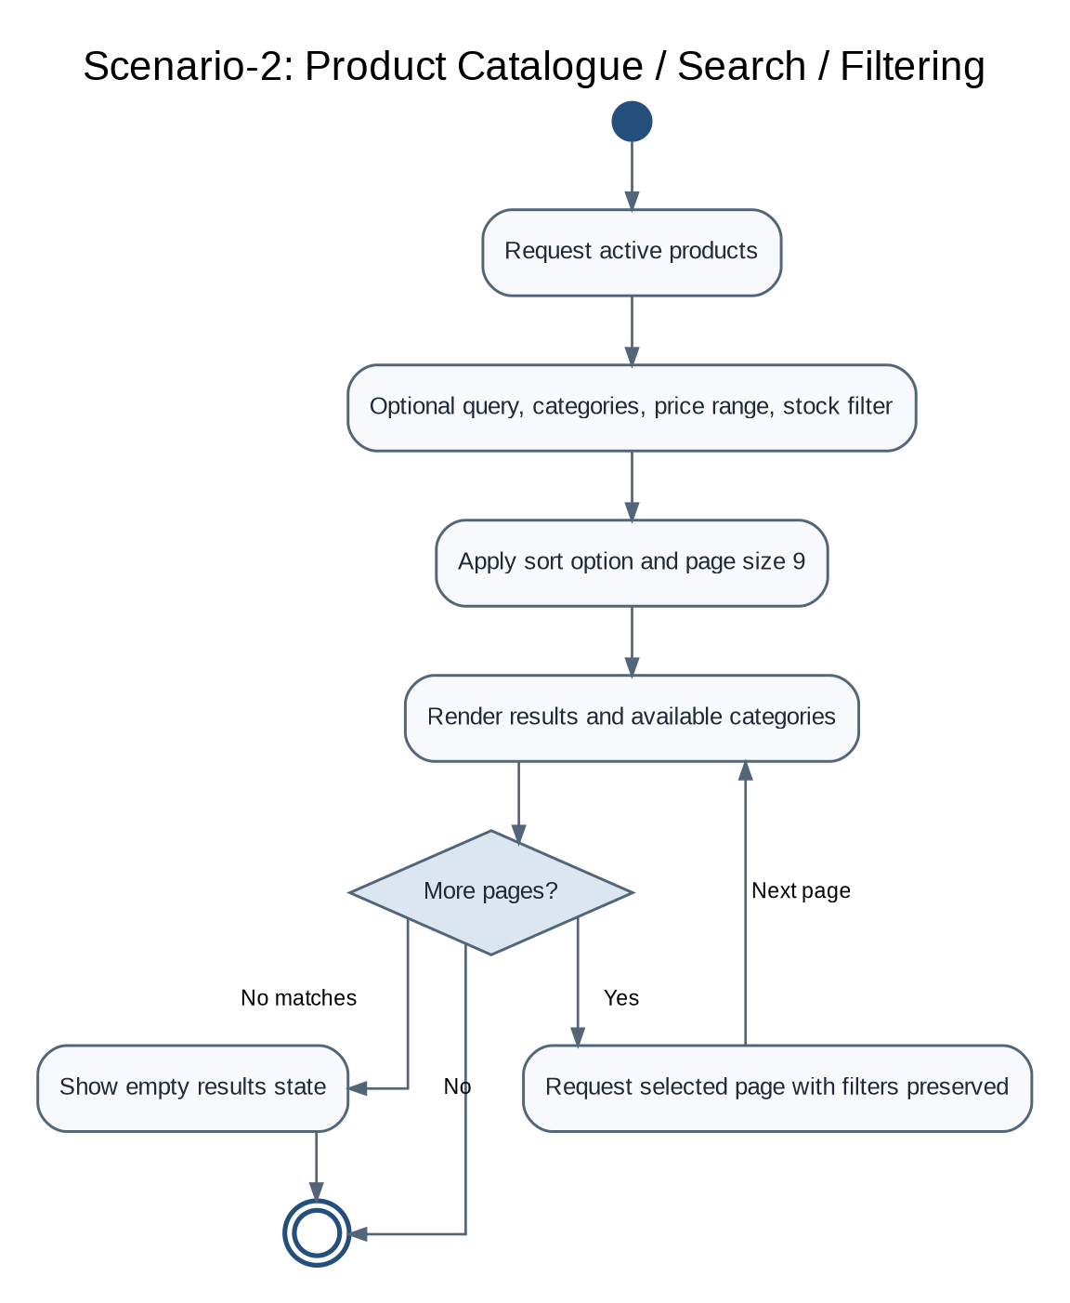
Figure 5.2.3: Scenario-2: Product Catalogue / Search / Filtering
Catalogue requests begin with active products. Search and filter parameters are applied server-side, and the result set is sorted and paginated before returning to the storefront.

Scenario-3: Product Detail / Ratings / Related Products
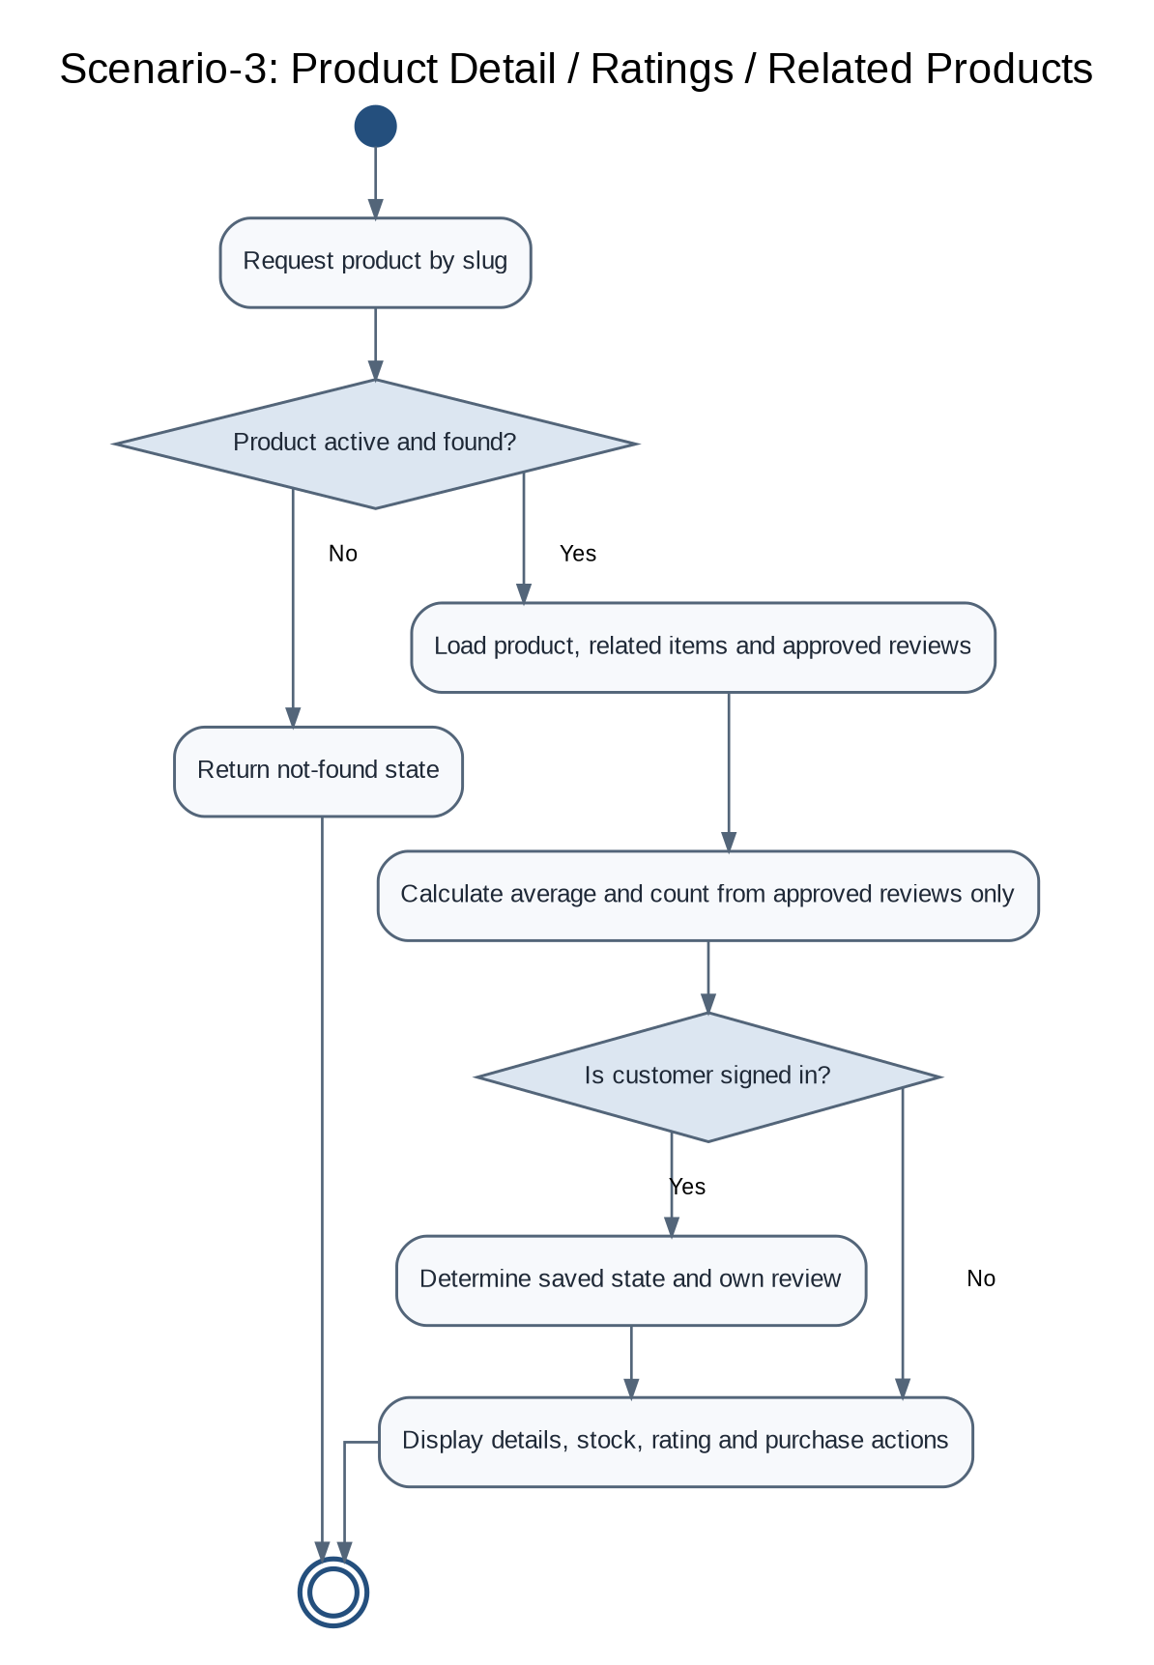
Figure 5.2.4: Scenario-3: Product Detail / Ratings / Related Products
The product-detail workflow rejects inactive or missing products. Average and count values are based on approved reviews only; own review and wishlist state are returned only to the signed-in customer.

Scenario-4: Cart Add / Update / Remove
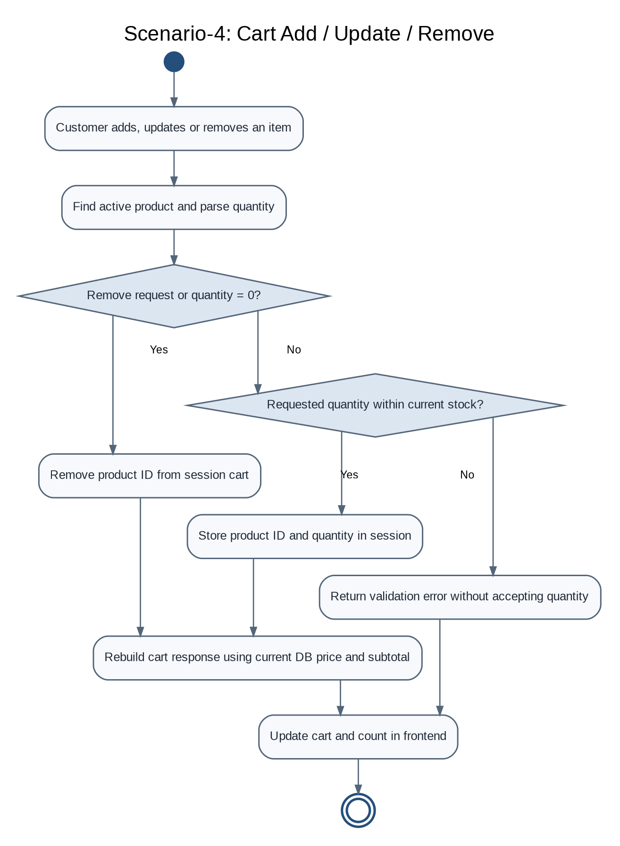
Figure 5.2.5: Scenario-4: Cart Add / Update / Remove
The browser requests a change, but the API enforces quantity rules and computes cart totals from current product values. The session does not contain trusted price data.

Scenario-5: Checkout and Cash-on-Delivery Order
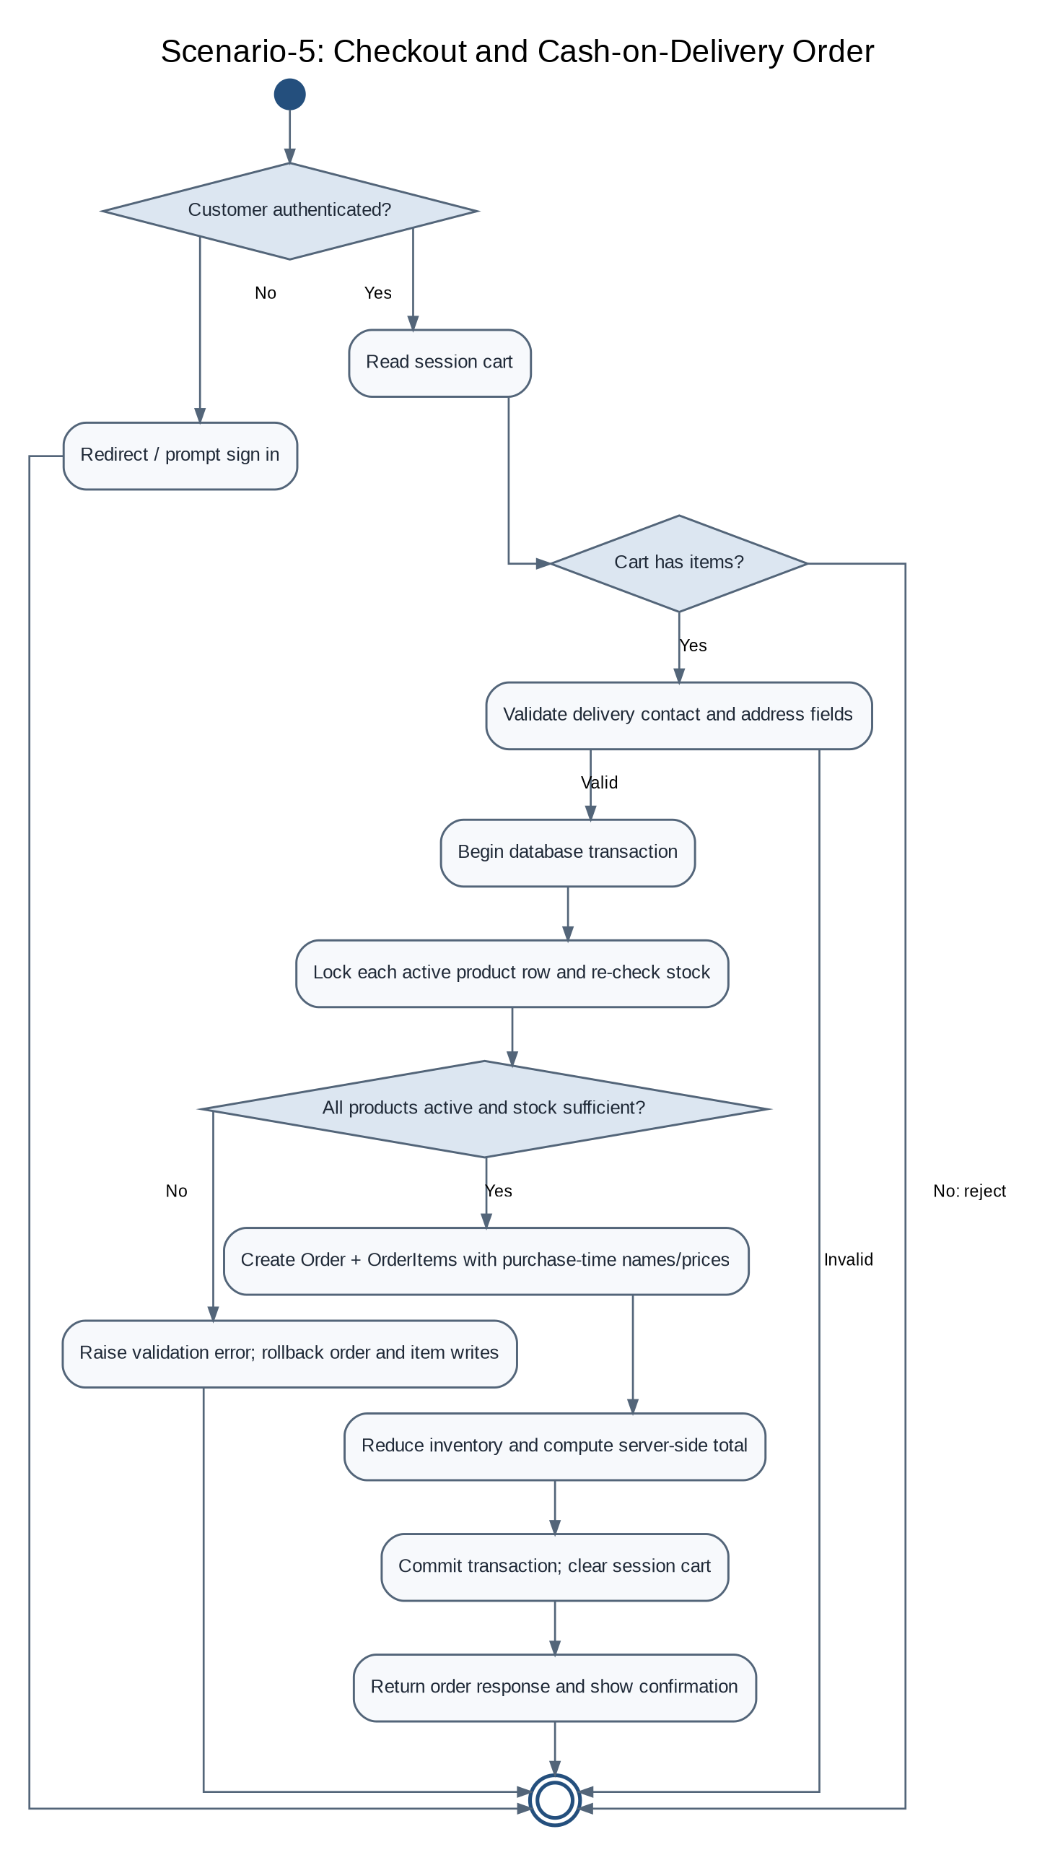
Figure 5.2.6: Scenario-5: Checkout and COD Order Creation
Checkout is the key integrity boundary: the server validates delivery data, locks products and rechecks inventory inside a transaction. Any invalid item aborts order creation; successful commit updates stock and clears the session cart.

Scenario-6: Order History / Order Detail
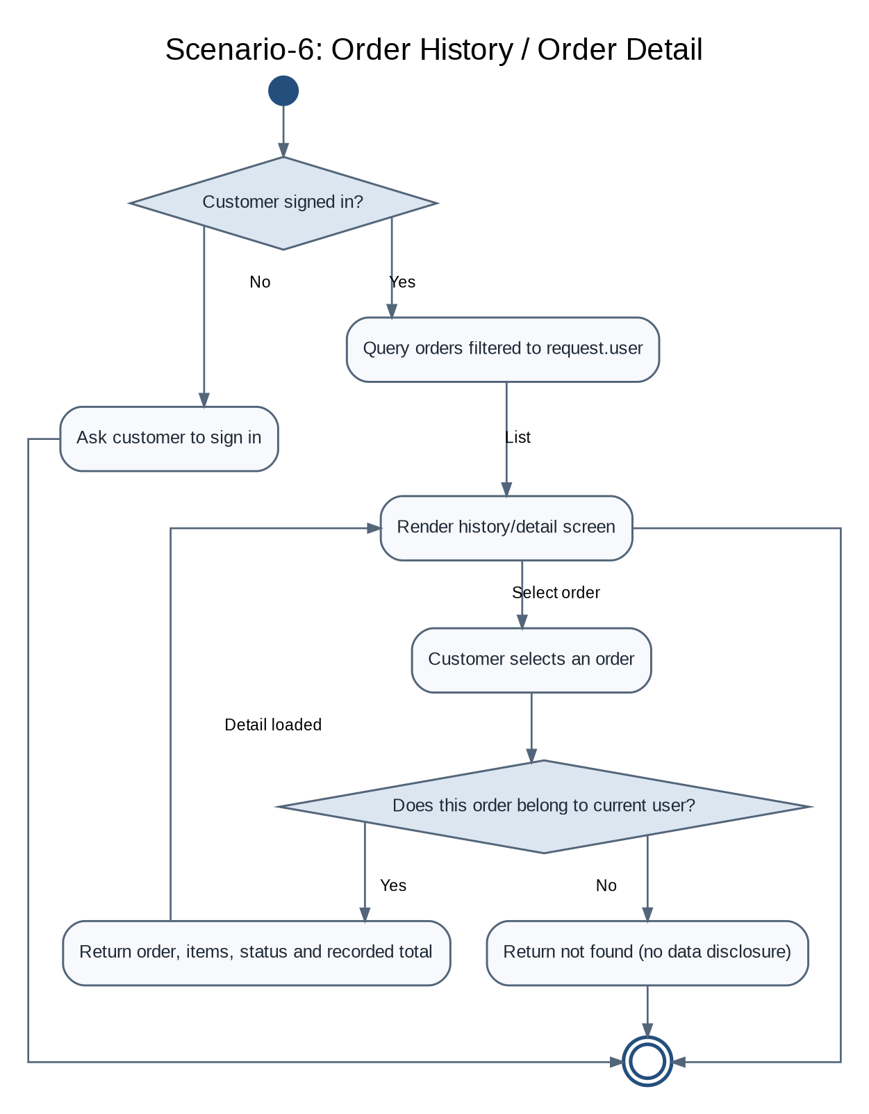
Figure 5.2.7: Scenario-6: Order History / Order Detail
Order visibility is scoped to the current authenticated account. An order ID alone is insufficient for access; the owner is included in the backend lookup.

Scenario-7: Wishlist Add / Remove / View
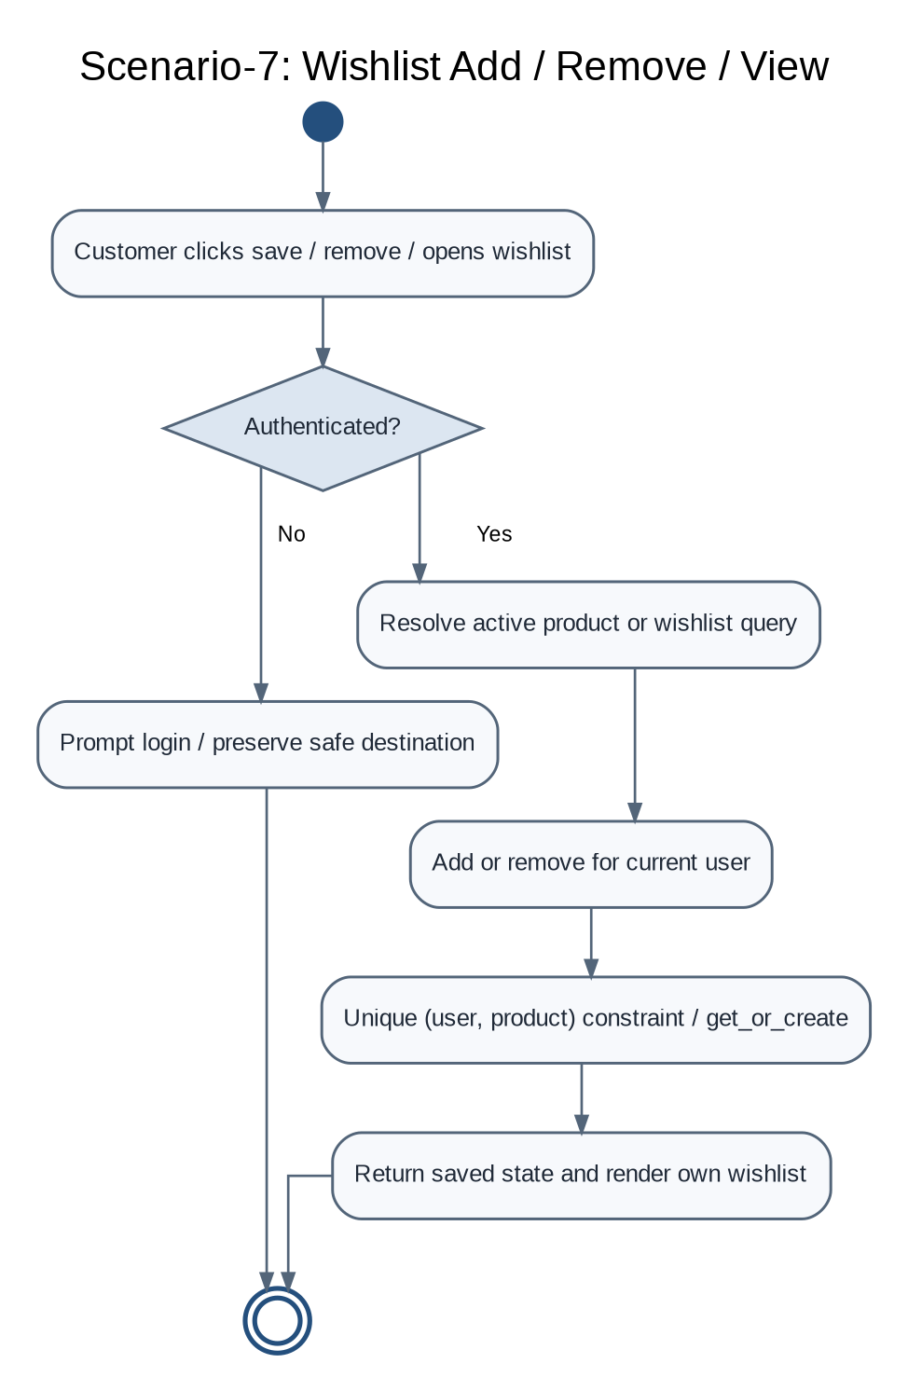
Figure 5.2.8: Scenario-7: Wishlist Add / Remove / View
Wishlist reads and writes require authentication. The unique pair constraint prevents duplicate rows, and deletion only targets the current user’s product entry.

Scenario-8: Customer Review Submission / Update
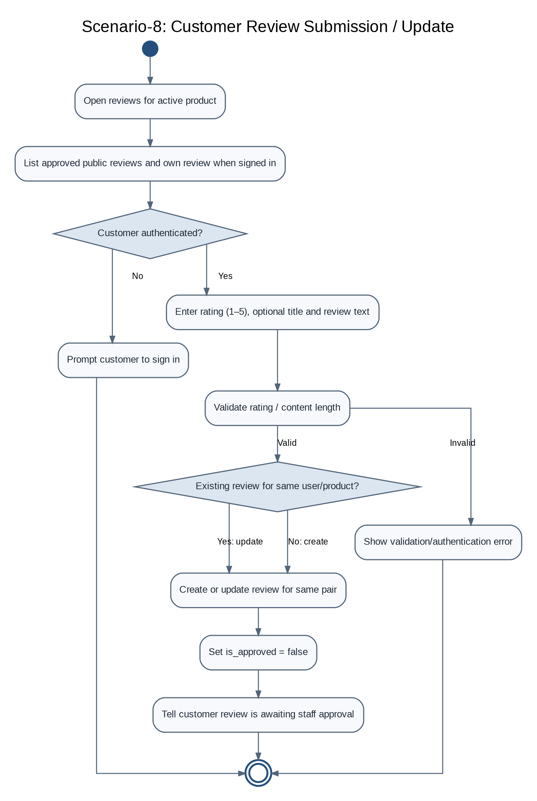
Figure 5.2.9: Scenario-8: Customer Review Submission / Update
Reviews are upserted for the unique customer/product pair. Every create or update resets approval to false so edited content must pass moderation again.

Scenario-9: Staff Review Moderation
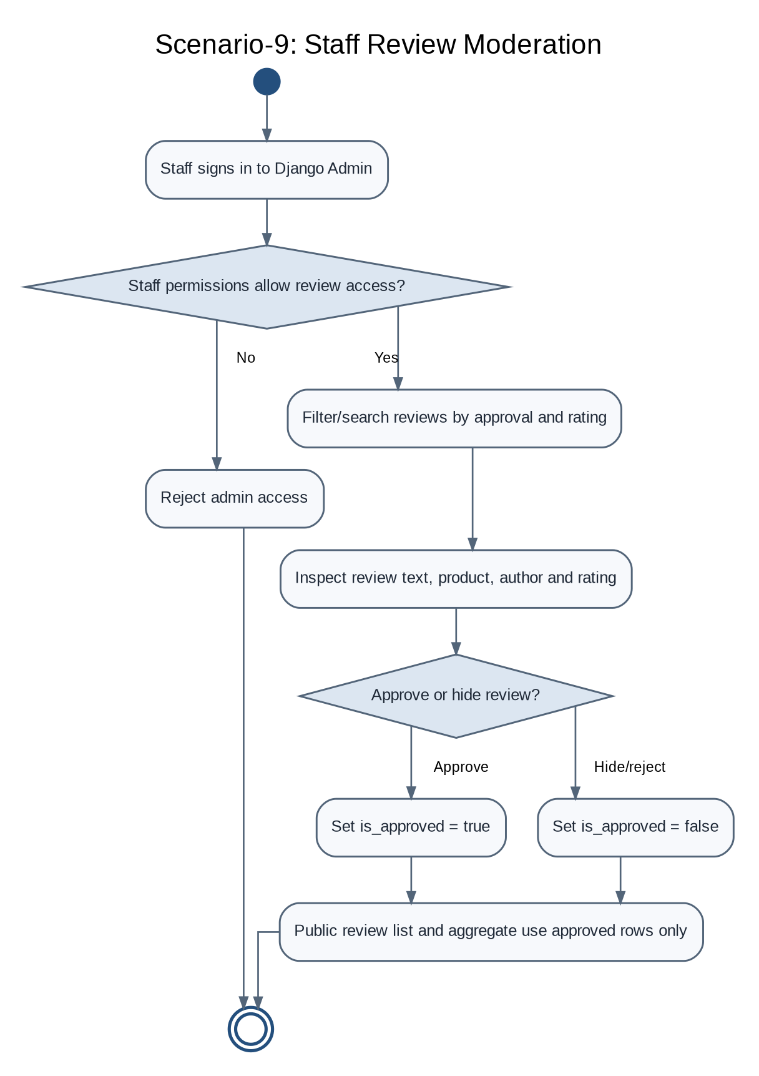
Figure 5.2.10: Scenario-9: Staff Review Moderation
Staff permissions gate review administration. Approved reviews are public and contribute to aggregates; hidden or pending reviews do not appear in public review lists.

Scenario-10: Profile Viewing / Editing
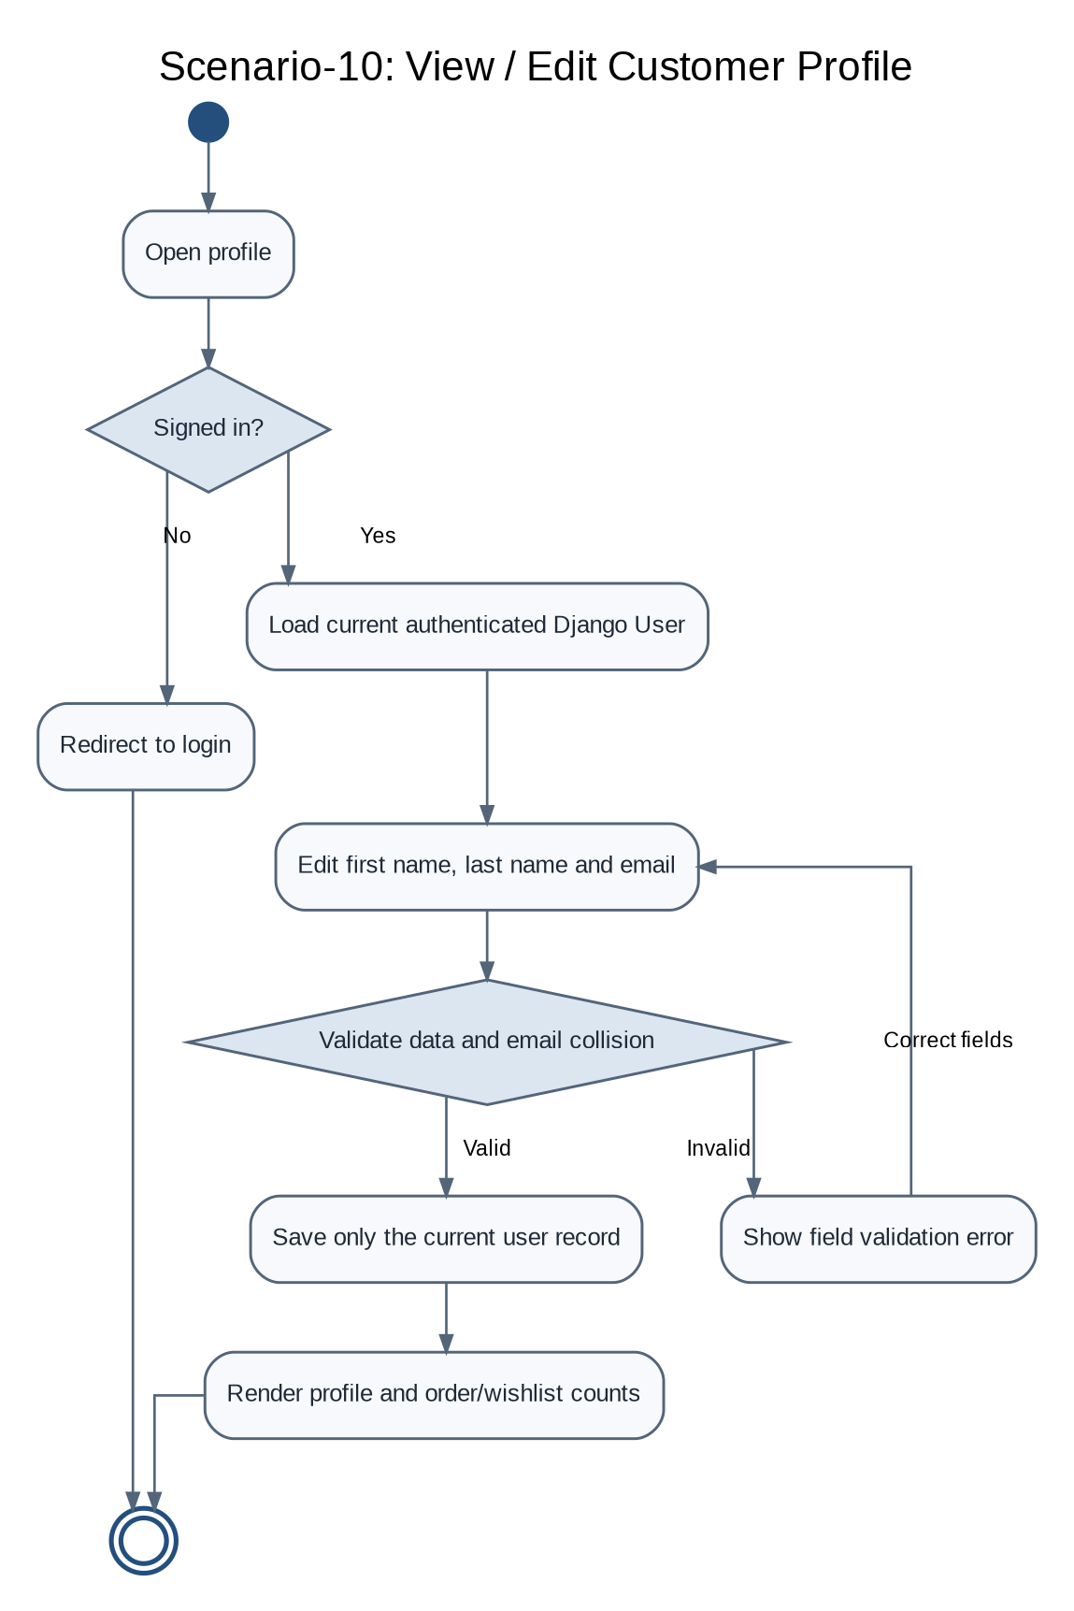
Figure 5.2.11: Scenario-10: Profile Viewing / Editing
Profile changes operate on the current authenticated Django User instance, including first name, last name and email. The email collision check is implemented at form/application level.

Scenario-11: Staff Product / Inventory Management
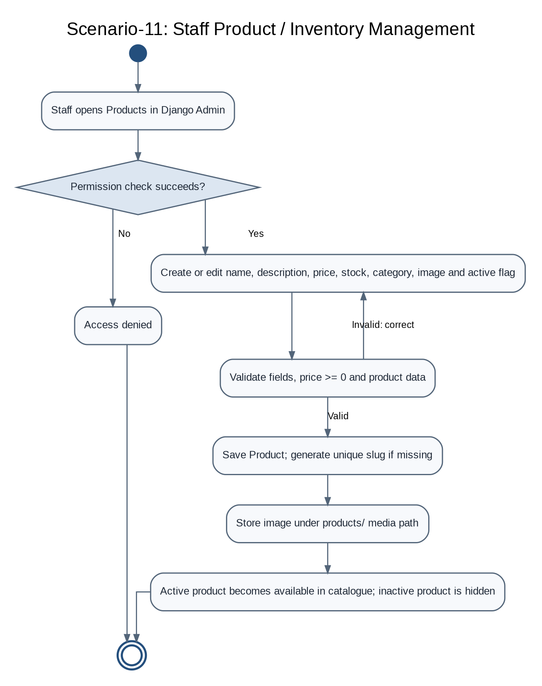
Figure 5.2.12: Scenario-11: Staff Product / Inventory Management
Product management is performed in Django Admin. The category is a text field, not a separate Category model. Active status determines whether a product is customer-visible.

Scenario-12: Staff Order Status Management
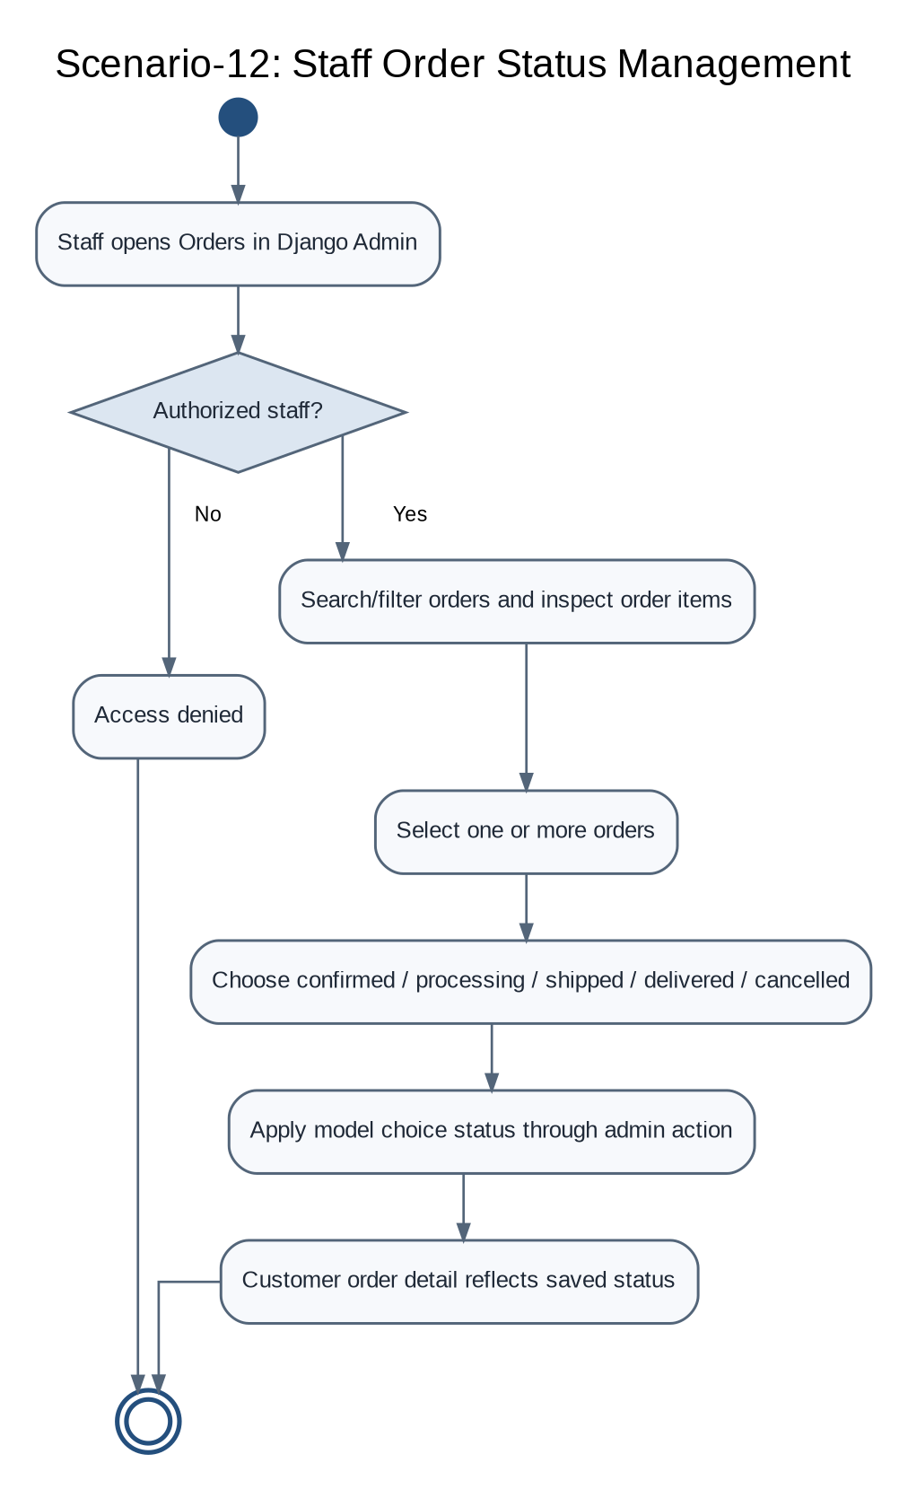
Figure 5.2.13: Scenario-12: Staff Order Status Management
Django Admin provides order list/search/filter and bulk status actions. The customer-facing order screens read the updated persisted status.

5.3 Database Design

UML Class Diagram (Entity Relationships)
The persistent domain model includes the standard Django User model, Product, Order, OrderItem, WishlistItem and Review. The cart is intentionally not modeled as a relational Cart/CartItem table: it is stored in Django session data as product IDs and quantities. Product categories are also represented by a text field rather than a separate Category entity. Django’s internal session table is included in the concept diagram to explain runtime cart storage; it is not a business-domain cart-line table.
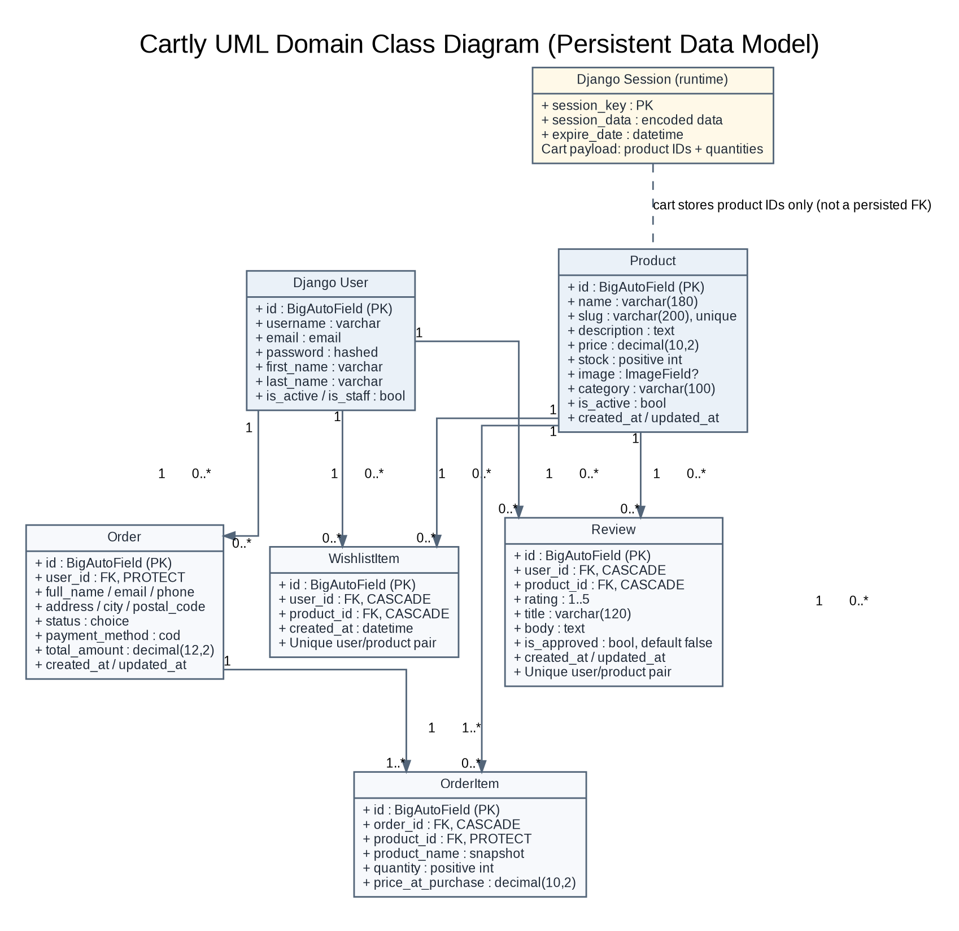
Figure 5.3: Cartly UML Domain Class Diagram / Entity Relationship Model

Data Dictionary

User Table (Django Authentication Model)
Field Name | Data Type | Constraints | Description
id | BIGINT / BigAutoField | Primary Key | Django-generated user identifier.
username | VARCHAR | Unique in Django auth | Internal account name; registration generates it from the email prefix if absent.
email | EMAIL / VARCHAR | Required by Cartly form; uniqueness checked by form logic | Login and account contact email. The inspected model uses Django User; email uniqueness is checked at application level.
password | VARCHAR / hash | Not null | Django-managed password hash; never returned to customer API.
first_name | VARCHAR | Optional | Customer first name, editable in profile.
last_name | VARCHAR | Optional | Customer last name, editable in profile.
is_active | BOOLEAN | Django default | Account availability state.
is_staff / is_superuser | BOOLEAN | Django permissions | Controls staff/admin access through Django authorization.
date_joined | DATETIME | Django-managed | Account creation time.

Product Table
Field Name | Data Type | Constraints | Description
id | BIGINT | PK | Unique product identifier.
name | VARCHAR(180) | Not null | Customer-visible product name.
slug | VARCHAR(200) | Unique; may be auto-generated | Stable product URL key.
description | TEXT | Not null | Product details used for search and detail presentation.
price | DECIMAL(10,2) | MinValueValidator 0.00 | Current selling price; server value used for cart/order totals.
stock | Positive Integer | Default 0 | Available inventory quantity.
image | ImageField | Blank / nullable | Uploaded image under products/ media path.
category | VARCHAR(100) | Blank allowed; db_index | Category label stored directly as text.
is_active | BOOLEAN | Default true | Controls public catalogue/detail visibility.
created_at | DATETIME | Auto-created; ordering newest first | Product creation timestamp.
updated_at | DATETIME | Auto-updated | Last product update time.
Indexes | Database index | (is_active, category), (name) | Support common catalogue visibility/search paths.

Order Table
Field Name | Data Type | Constraints | Description
id | BIGINT | PK | Unique order reference.
user_id | FK -> User | PROTECT; required | Account that placed the order.
full_name | VARCHAR(160) | Required | Delivery contact name captured at checkout.
email | EMAIL | Required | Contact email stored on order.
phone | VARCHAR(30) | Required | Delivery coordination phone number.
address | VARCHAR(255) | Required | Delivery street/house address.
city | VARCHAR(100) | Required | Delivery city.
postal_code | VARCHAR(20) | Blank allowed | Optional postal code.
status | VARCHAR(20) | Choice; default pending; indexed | pending, confirmed, processing, shipped, delivered, cancelled.
payment_method | VARCHAR(10) | Choice; default cod | Cash on Delivery is the only configured payment method.
total_amount | DECIMAL(12,2) | Default 0.00; non-negative validator | Server-computed order total.
created_at / updated_at | DATETIME | Auto-managed; newest first | Order creation and last update timestamps.

OrderItem Table
Field Name | Data Type | Constraints | Description
id | BIGINT | PK | Unique line-item identifier.
order_id | FK -> Order | CASCADE; required | Parent order; deletion of order cascades to order items.
product_id | FK -> Product | PROTECT; required | Linked product; historical order lines prevent product deletion.
product_name | VARCHAR(180) | Required | Purchase-time product name snapshot.
quantity | Positive Integer | Minimum 1 | Units purchased.
price_at_purchase | DECIMAL(10,2) | Non-negative validator | Unit price captured when the order is created.
line_total | Derived decimal | Read-only property | price_at_purchase multiplied by quantity.

WishlistItem Table
Field Name | Data Type | Constraints | Description
id | BIGINT | PK | Unique wishlist row identifier.
user_id | FK -> User | CASCADE | Owner of this saved item.
product_id | FK -> Product | CASCADE | Saved product.
created_at | DATETIME | Auto-created, newest first | Timestamp when item was saved.
user_id + product_id | Unique constraint | unique_wishlist_product_per_user | A customer cannot save the same product twice.

Review Table
Field Name | Data Type | Constraints | Description
id | BIGINT | PK | Unique review identifier.
user_id | FK -> User | CASCADE | Author/customer who submitted the review.
product_id | FK -> Product | CASCADE | Product being reviewed.
rating | Positive Small Integer | Min 1, max 5 | Star rating.
title | VARCHAR(120) | Model max length; form title optional and max 80 | Short review title.
body | TEXT | Model max 2000; form max 1000 and min 10 | Review content.
is_approved | BOOLEAN | Default false; indexed | Moderation state; public lists include true only.
created_at / updated_at | DATETIME | Auto-managed, newest first | Review creation and modification times.
user_id + product_id | Unique constraint | unique_review_per_user_product | One review record per customer/product pair; edits reset approval.

Django Session Cart (Runtime State)
Cartly does not persist a `Cart` or `CartItem` business model. The cart service stores a session key named `cart`, mapping product ID strings to quantities. At read/checkout time, active Product rows are resolved from PostgreSQL, current database prices are used, and invalid/missing products are skipped or rejected according to the endpoint. This design avoids treating client/session price data as authoritative, but a cart is tied to the current session rather than stored as an account-level saved cart.

Database Integrity Rules
- Product slug must be unique. Missing slugs are generated from the product name, with a numeric suffix added on collision.
- Product price is validated to be non-negative; stock is a positive-integer field that can hold zero.
- One wishlist row exists per (user, product) pair; `get_or_create` and a database unique constraint work together.
- One review row exists per (user, product) pair; review create/update logic reuses the existing record and resets public approval to false.
- Orders reference an existing user with `PROTECT`; order items cascade from order but protect their referenced product.
- Checkout recalculates totals from current Product records within `transaction.atomic()` and uses `select_for_update()` to recheck stock before decrementing inventory.
- Order list/detail queries are scoped to the current user. Wishlist queries and deletions are also scoped to the current user.
- Public review results and rating aggregates are filtered by `is_approved=True`.
- Django session cart is runtime state and is not a relational CartItem table. Session expiry/cleanup is handled by Django’s session framework.

6. Technical Implementation

6.1 Backend / Data Interaction Documentation

6.1.1 Backend Organization
The Django backend is separated into domain applications, an API application, configuration and static/media integration. `apps.api` provides the JSON endpoints, serializers and middleware support. Domain apps are responsible for their own models, forms, page views, admin registrations and related services. Product and order business rules remain on the server; the browser sends action intent and receives structured data rather than authoritative prices or stock counts.
backend/
├── manage.py # Django CLI
├── requirements.txt # Django, DRF, psycopg, dotenv, Pillow, CORS
├── .env.example # Environment template
├── config/
│ ├── settings.py # DB, static/media, sessions, CSRF, CORS
│ ├── urls.py # API + app routes + admin
│ ├── asgi.py
│ └── wsgi.py
└── apps/
├── api/ # JSON API, serializers, CSRF middleware, tests
├── accounts/ # Registration, email login, profile, account routes
├── products/ # Product model, catalogue views, admin, tests
├── cart/ # Session cart service and summary context
├── orders/ # Order / OrderItem, checkout form, admin actions
├── wishlists/ # WishlistItem and wishlist behavior
└── reviews/ # Review, form, public filtering and staff moderation

6.1.2 RESTful API Endpoints
Base URL: `http://127.0.0.1:8000/api/v1/`. These routes are defined in `backend/apps/api/urls.py`. Requests that mutate state must carry a valid CSRF token (`X-CSRFToken`) and include the session cookies. For separately hosted frontend development, configure matching CORS and CSRF trusted origins.
Module | HTTP Method | Endpoint | Purpose | Authentication
Auth / CSRF | GET | /csrf/ | Obtain a CSRF token; response is not cached. | Public
Accounts | POST | /auth/register/ | Create account; successful registration establishes a session. | Public + CSRF
Accounts | POST | /auth/login/ | Email/password login using Django auth. | Public + CSRF
Accounts | POST | /auth/logout/ | End the current session. | Session / CSRF
Accounts | GET | /auth/me/ | Return current user or `{user: null}` for anonymous session. | Optional session
Accounts | GET, PATCH | /auth/profile/ | View/update current user first name, last name and email. | Required
Home | GET | /home/ | Featured product, categories, popular and newest products. | Public
Products | GET | /products/ | Search, filter, sort and paginate active products. | Public
Products | GET | /products/<slug>/ | Product details and related products. | Public
Reviews | GET, POST | /products/<slug>/reviews/ | List approved reviews / submit or update own review. | GET public; POST signed-in + CSRF
Cart | GET | /cart/ | Return session cart items, count, total and availability flag. | Session
Cart items | POST, PUT, DELETE | /cart/items/<product_id>/ | Add, set quantity, or remove a cart item. | Session + CSRF
Wishlist | GET | /wishlist/ | Return current customer’s active saved products. | Required
Wishlist item | POST, DELETE | /wishlist/items/<product_id>/ | Save/remove product for the current customer. | Required + CSRF
Orders | GET, POST | /orders/ | List own orders / validate checkout and create COD order. | Required; POST + CSRF
Order detail | GET | /orders/<order_id>/ | Retrieve one order only if it belongs to current user. | Required

Catalogue Query Parameters
Parameter | Meaning | Notes
q | Search | Case-insensitive product name, description or category match.
category | Category filter | May be repeated; values are compared to the product category text.
min / max | Price range | Non-negative decimal minimum and maximum.
stock=1 | In-stock only | Filters products where stock is greater than zero.
sort | Ordering | newest, price-asc, price-desc, or rating; newest is the default API sort.
page | Pagination | Nine products per page in the API catalogue.

API Behavior Notes
- `ProductSerializer` exposes product ID, name, slug, description, current price, stock, image URL, category, `in_wishlist`, average rating and approved review count.
- `OrderSerializer` exposes delivery data, status and display label, payment method and display label, server total, item count, timestamps and related order items.
- The `my_review` value is included by the review listing endpoint only when the user is signed in; the public review list contains approved reviews only.
- There is no separate admin REST endpoint in the inspected `api/urls.py`; staff operations use Django Admin at `/admin/`.

6.1.3 Product Image Handling Rules
- Product images are stored using Django `ImageField` with `upload_to="products/"`; local development media is rooted under the repository media directory.
- The product serializer checks that a file exists in storage before returning its URL; missing images are serialized as null instead of a broken absolute URL.
- Django serves local media in DEBUG mode. Production deployments need an explicit media-serving/storage strategy and must not expose development-only settings.
- Pillow provides image handling. Upload size limits, image reprocessing and object storage can be strengthened if the deployment threat model or file volume requires them.

6.1.4 Catalogue Search and Filtering
Catalogue queries begin with `is_active=True`. The current implementation searches name, description and the category text using case-insensitive containment; category selections are exact matches. Valid non-negative min/max prices filter the Decimal price field. `stock=1` excludes products with no available stock. The API supports newest, price ascending, price descending and rating sort keys; pagination uses Django Paginator with nine results per page. Rating sorting and product aggregates use approved reviews only.

6.1.5 Cart and Checkout Transaction Rules
- The session cart stores only product identifiers and integer quantities. It does not store trusted unit prices; cart values are resolved from current active product rows.
- Cart addition validates quantity as at least one and checks how much stock remains beyond the quantity already in the cart. Quantity updates accept zero as removal and reject values above current stock.
- Checkout requires a signed-in user and at least one cart item. The form validates full name, email, phone, address, city and optional postal code.
- Inside `transaction.atomic()`, checkout creates the Order with a zero initial total, retrieves each active product using `select_for_update()`, and checks that the requested quantity remains available.
- For each cart item, OrderItem stores the product relation, snapshot product name, quantity and price-at-purchase. Inventory is decremented and the server recomputes the order total from current database prices.
- If a product is no longer active or the stock changed, validation aborts the operation and the transaction prevents partial order/stock state. After successful transaction completion, the cart session is cleared.
- Only Cash on Delivery is configured. The site does not integrate online payment processing, payment settlement or payment webhooks.

6.1.6 Staff Control and Review Moderation
- Product Admin: list display includes name, category, price, stock, active state and creation time; price, stock and active state are editable from the list. Search fields include product name, description and category; timestamps are read-only.
- Order Admin: provides search and filters, order items inline, read-only timestamps, and bulk actions to mark orders confirmed, processing, shipped, delivered or cancelled.
- Review Admin: can search product/user/title/body; filter by approval, rating and date; approve selected reviews or hide selected reviews. The approval value determines public visibility and the rating aggregate.
- User / Group and wishlist records are managed through standard or registered Django Admin models as configured in the source. No separate custom administrator website or system-wide analytics dashboard was confirmed in the inspected routes.

6.2 Relationship & Access Rules
Role / State | Key Permissions | Restricted Actions
Visitor / Anonymous | Browse active products; read product detail and approved reviews; maintain a session cart; obtain CSRF token; register or log in. | Cannot edit profile, use the persisted wishlist, submit a review, create an order, or read private order data.
Authenticated Customer | Update own profile; manage current session cart; save/remove wishlist items; submit/update own review; checkout COD; list/detail own orders. | Cannot read another customer’s order or wishlist; cannot force a review to be public; cannot use staff admin without permissions.
Store Staff | Access permitted Django Admin models to manage catalog/inventory, inspect/update orders, manage users/groups and wishlist records, approve/hide reviews. | No access beyond the account’s Django staff/model permissions. API frontend visibility is not an authorization mechanism.
Superuser / Authorized Administrator | Full Django Admin capabilities granted by superuser status and configured model permissions. | Credentials and secret keys must remain private; production configuration and data changes must be handled carefully.

6.3 Frontend Organization
The storefront is static HTML with CSS and native JavaScript ES modules. `index.html` is the landing page; `pages/` contains the product catalogue, product detail, profile, cart, checkout, orders, order detail, order success, wishlist and review pages. `js/main.js` loads common account/cart/wishlist state, renders the shared shell and dynamically imports the correct page module based on the body `data-page` value. `js/config.js` defines page URLs and the API origin. Shared API modules handle request/CSRF logic; components contain the reusable shell; page modules own feature-specific interactions.
Frontend/
├── index.html # Home / featured and popular products
├── pages/
│ ├── products.html # Catalogue, search, filters and pagination
│ ├── product_detail.html # Product detail / add cart / reviews summary
│ ├── profile.html # Customer profile
│ ├── cart.html # Session cart management
│ ├── checkout.html # Delivery form / COD order summary
│ ├── orders.html # Order history
│ ├── order.html # Order detail
│ ├── order_success.html # Order confirmation
│ ├── wishlist.html # Saved products
│ └── reviews.html # Review list and submission form
├── css/
│ ├── base.css # Reset and typography
│ ├── layout.css # Containers, grid and shared layout
│ ├── components.css # Buttons, forms, cards and alerts
│ ├── pages.css # Page-specific presentation
│ └── responsive.css # Mobile / tablet breakpoints
├── js/
│ ├── main.js # Shared initialization / page router
│ ├── config.js # API origin and page URL configuration
│ ├── api/ # API client, auth, cart, products, orders, wishlist
│ ├── components/ # Shared storefront shell and product card
│ └── pages/ # Home, catalogue, account, commerce, community
└── assets/ # Logo, empty-state and static assets

6.4 Administration Frontend Organization
Cartly’s administration frontend is Django Admin, not a parallel handcrafted admin frontend folder. It is served at `/admin/` and uses Django’s built-in model forms, list views, filters, search, inline models and bulk actions. Customization resides in app-specific `admin.py` files. The customer-facing static frontend should not copy admin-only controls into its own JavaScript or assume that a hidden link protects a server action.
backend/apps/
├── products/admin.py # Product search, filters, price/stock/active fields
├── orders/admin.py # Order list, OrderItem inline, bulk order-status actions
├── reviews/admin.py # Review approval filters, search, approve/hide actions
├── wishlists/admin.py # Wishlist item administration (where registered)
└── accounts/admin.py # Django account administration / standard User and Group

7. Quality Assurance & Testing

7.1 Test Case Scenarios
The repository contains automated Django tests in the API and product applications. The test source covers CSRF/session authentication, frontend static-file structure, active product visibility, product data serialization, cart quantity limits, profile updates, wishlist access, checkout stock changes and order ownership. The statuses below indicate evidence in source and whether a test is recommended; they do not claim that tests passed. The complete suite should be executed locally against a configured PostgreSQL test database before release.
Test ID | Test Description | Input / Condition | Expected Result | Status
TC-01 | Registration with valid fields | Full name, unique email, matching strong password | A User is created and a session is established. | Present in API test source; execution not verified
TC-02 | Registration without CSRF | POST without a CSRF header | Request is rejected with 403. | Present in API test source; execution not verified
TC-03 | Duplicate email registration | Email already registered (case-insensitive) | Form reports validation error; no duplicate application account. | Recommended
TC-04 | Login by email | Valid email and password | User is authenticated in the session. | Present in API test source; execution not verified
TC-05 | Invalid login | Unknown email or incorrect password | Login is denied with a useful error. | Recommended
TC-06 | Logout | Authenticated session posts logout | Session auth state is cleared. | Recommended
TC-07 | Current-user endpoint | Anonymous and authenticated requests | Anonymous user is null; signed-in user fields are returned. | Partly covered in API test source
TC-08 | Profile update authorization | Anonymous GET /profile; signed-in PATCH | Anonymous is denied; current User fields update. | Present in API test source; execution not verified
TC-09 | Active product list | Product is active | Product appears in list with price and safe image value. | Present in Product/API test source
TC-10 | Inactive product omitted | Set is_active=false | Product is not listed publicly. | Present in Product test source
TC-11 | Inactive product detail | Request detail by inactive slug | API returns 404. | Present in Product test source
TC-12 | Search/filter/sort/page | Search term and filter/query parameters | Only matching products are returned in requested order/page. | Recommended / manual verification
TC-13 | Missing image file | ImageField points to absent storage object | Serializer returns null instead of a broken image URL. | Present in API test source
TC-14 | Add cart item | Quantity within stock | Session cart count and total update correctly. | Present in API test source
TC-15 | Cart quantity above stock | Combined cart quantity exceeds inventory | API returns validation error and keeps cart valid. | Present in API test source
TC-16 | Cart set quantity to zero | PUT quantity 0 | Item is removed from session. | Recommended
TC-17 | Wishlist requires authentication | Anonymous GET wishlist | Request is denied. | Present in API test source
TC-18 | Wishlist save/remove | Signed-in user saves then removes a product | Saved state toggles; wishlist becomes empty after removal. | Present in API test source
TC-19 | Wishlist isolation | User A tries to affect User B saved entry | Operations only affect the current user’s row. | Recommended / manual verification

7.1 Test Case Scenarios (Continued)
Test ID | Test Description | Input / Condition | Expected Result | Status
TC-20 | Approved review list | Product has approved and pending review rows | Public review list includes approved reviews only. | Recommended / manual verification
TC-21 | Review submit while anonymous | Anonymous POST review | API denies the request; session-auth responses may use 403 when no authentication header is available. | Behavior present in API source; execution not verified
TC-22 | Review create/update | Customer submits one review twice | Existing user/product record is updated, not duplicated. | Model constraint + API logic present
TC-23 | Review updated visibility | Customer edits an approved review | is_approved resets to false until staff action. | Present in API source; execution not verified
TC-24 | Review rating validation | Rating below 1 or above 5 | Invalid data is rejected by validation. | Recommended
TC-25 | Wishlist uniqueness | Repeat save same user/product | No duplicate row due to get_or_create and unique constraint. | Model/API logic present
TC-26 | Checkout requires login | Anonymous POST /orders/ | Order creation denied. | Present in API source; execution not verified
TC-27 | Empty cart checkout | Authenticated POST with no cart items | Validation rejects the request; no Order is created. | Present in API source; execution not verified
TC-28 | Successful COD order | Valid address + stocked cart | Order/OrderItem saved, total computed and stock reduced. | Present in API test source; execution not verified
TC-29 | Stock changed before checkout | Cart quantity becomes larger than current stock | Checkout rejects; no order is created and stock is unchanged. | Present in API test source; execution not verified
TC-30 | Order detail privacy | User B requests User A order ID | Order is not disclosed; API returns 404. | Present in API test source; execution not verified
TC-31 | Order history privacy | Two customers have orders | Each list contains only the current user’s orders. | API query is user-scoped; recommended test
TC-32 | Order total integrity | Tamper with client-side total / price | Backend calculates total from DB prices and quantity. | Code inspection; add regression test
TC-33 | Cart cleared after order | Place successful checkout | Session cart is cleared only after transaction commit. | Code inspection; add regression test
TC-34 | Staff order bulk action | Staff marks order shipped/delivered/cancelled | Persisted status updates to the selected choice. | Admin code present; manual verification
TC-35 | Staff review approval | Approve/hide selected review rows | is_approved toggles and public aggregate changes accordingly. | Admin code present; manual verification
TC-36 | Static page markers | Run static-file structure test | Expected IDs exist in all listed page forms/containers. | Present in API test source
TC-37 | Root redirect | GET / | Redirect points to /static/index.html. | Present in API test source
TC-38 | Custom not-found page | Request a missing URL with DEBUG=False | Custom not-found content is returned. | Present in Product test source

7.2 Requirements Traceability Matrix (RTM)
FR ID | Feature | Test ID | Test Case Coverage | Status
FR01–FR03 | Registration, login, profile | TC-01 to TC-08 | Auth, CSRF, profile validation and ownership. | Mapped; execute suite
FR04–FR08 | Home, catalogue, search and detail | TC-09 to TC-13 | Active products, safe media, query and rating values. | Mapped; execute + extend
FR09–FR10 | Session cart and stock validation | TC-14 to TC-16 | Quantity cap, current price calculation and removal. | Mapped; execute + extend
FR11–FR13 | COD checkout and order access | TC-26 to TC-33 | Authentication, stock lock, transaction, server total and ownership. | Mapped; execute + extend
FR14–FR15 | Wishlist | TC-17, TC-18, TC-19, TC-25 | Authentication, per-user isolation and uniqueness. | Mapped; execute + extend
FR16–FR18 | Reviews and rating aggregate | TC-20 to TC-24, TC-35 | One review per product/user; hidden until approval; approved-only aggregates. | Mapped; add automated tests
FR19 | Product administration | Product test suite + TC-34 | Admin product edits and stock updates. | Partly mapped; manual verification
FR20 | Order administration | TC-34 | Admin bulk actions and status visibility. | Mapped in source; manual verification
FR21 | Review / account admin | TC-35 | Moderation actions and user/group administration. | Mapped in source; manual verification
FR22–FR24 | CSRF, media and error handling | TC-02, TC-13, TC-36 to TC-38 | CSRF rejection, missing media, static page and custom 404 behavior. | Mapped; execute suite

8. Individual Contribution
The public repository identifies Cartly as the project maintained by its owner, and the source is organized as a full-stack implementation. The following contribution summary describes the responsibilities evidenced by the current codebase; it is not a claim that external contributors or formal team roles are recorded in the repository.
Name | Student ID | Role | Contribution
MD. Shoaib Sikder | Not provided | Project Developer / Full-Stack Developer | Project structuring; HTML/CSS/vanilla JavaScript storefront; Django and Django REST Framework APIs; PostgreSQL data models and migrations; session authentication and CSRF handling; catalogue filtering; session cart and transactional COD checkout; wishlist and moderated reviews; Django Admin operations; test organization and project documentation.

Technical Challenges
- Keeping the session cart separate from trusted product data so that submitted quantities do not carry authoritative prices.
- Protecting checkout from stale inventory by locking product rows and performing validation, order creation and stock decrement inside a transaction.
- Keeping order and wishlist endpoints scoped to the authenticated owner rather than relying on frontend navigation or unguessable IDs.
- Ensuring that product ratings/counts are based only on approved reviews and that customer edits return a review to pending moderation.
- Coordinating the static module-based frontend with a same-host Django API and configuring CSRF/CORS correctly for a separate local preview origin.

Learning Outcomes
Cartly demonstrates the connection between requirements writing, data modeling, API design, session state, security controls, business-rule validation, transaction safety, frontend modularity, admin workflows and test design. It also makes clear which responsibilities remain in the backend even when the user interface is implemented with plain JavaScript.

9. Conclusion & Future Work

9.1 Conclusion
Cartly provides an integrated shopping workflow: visitors can discover active products; customers can maintain a session cart, save items, submit reviews and place COD orders; staff can manage inventory, review order status and moderate reviews. The key business rules are implemented server-side, with PostgreSQL as the persistent source of truth. The current repository also includes focused tests for several important API, CSRF, frontend structure, cart and checkout cases. A final release should run those tests in the intended environment and extend coverage for remaining review/admin edge cases.

9.2 Future Enhancements (Version 2.0)
- Add a real payment provider only after choosing a provider, defining payment states and implementing signed webhooks and idempotent payment handling.
- Introduce normalized Category records if the product taxonomy grows beyond the current category text field.
- Add delivery charge rules, coupon/discount logic and order cancellation rules with explicit refund/inventory policy.
- Add customer order and dispatch notifications by email after defining privacy, retry and failure handling.
- Add image size/dimension limits, optional image transformation and production object storage for uploaded product images.
- Add automated review-focused tests for pending visibility, edited-review reset, rating validation, uniqueness and approved-only aggregates.
- Add structured logging, error monitoring, production CORS/CSRF origin validation, secure cookie/HTTPS configuration and a documented deployment checklist.
- Consider PostgreSQL full-text search, caching and more advanced product ranking only after profiling the current catalogue workload.

10. Appendices

Appendix A: Project Repository and Source Review
Repository: https://github.com/ShoaibSikder/Cartly
The documentation was grounded in the repository README and the following implementation areas reviewed from the current main branch:
- `backend/apps/products/models.py`, `views.py`, `admin.py`, and `tests.py` — product fields, active catalogue filtering, search parameters, slug generation, images and tests.
- `backend/apps/orders/models.py`, `forms.py`, and `admin.py` — COD order fields, order items, status choices and staff status actions.
- `backend/apps/wishlists/models.py` and `backend/apps/reviews/models.py`, `forms.py`, `admin.py` — uniqueness constraints, rating validation and moderation.
- `backend/apps/api/urls.py`, `views.py`, `serializers.py`, `middleware.py`, and `tests.py` — JSON endpoints, session auth, CSRF, cart actions, user-scoped orders and transaction logic.
- `backend/apps/accounts/forms.py` and `views.py` — email registration/login and profile editing.
- `backend/apps/cart/cart.py` — session cart representation and live price calculation.
- `backend/config/settings.py` and `urls.py` — PostgreSQL, session auth, CSRF/CORS, static/media and route configuration.
- `Frontend/index.html`, `Frontend/pages/checkout.html`, `Frontend/js/main.js` and `Frontend/js/config.js` — static shell, modules, routing and API-origin selection.
Repository review date: 22 October 2026. Source URLs:
- https://github.com/ShoaibSikder/Cartly/blob/main/README.md
- https://raw.githubusercontent.com/ShoaibSikder/Cartly/main/backend/apps/api/views.py
- https://raw.githubusercontent.com/ShoaibSikder/Cartly/main/backend/apps/api/serializers.py
- https://raw.githubusercontent.com/ShoaibSikder/Cartly/main/backend/apps/products/models.py
- https://raw.githubusercontent.com/ShoaibSikder/Cartly/main/backend/apps/orders/models.py
- https://raw.githubusercontent.com/ShoaibSikder/Cartly/main/backend/apps/wishlists/models.py
- https://raw.githubusercontent.com/ShoaibSikder/Cartly/main/backend/apps/reviews/models.py
- https://raw.githubusercontent.com/ShoaibSikder/Cartly/main/backend/config/settings.py
- https://raw.githubusercontent.com/ShoaibSikder/Cartly/main/Frontend/js/main.js

Appendix B: Backend Setup
Clone the repository and create a Python virtual environment. Commands below follow the README. Use PowerShell on Windows; adjust activation for your shell.
# 1. Clone repository and enter backend
git clone https://github.com/ShoaibSikder/Cartly.git
cd Cartly/backend

# 2. Create and activate virtual environment (Windows PowerShell)
python -m venv .venv
.\.venv\Scripts\Activate.ps1

# 3. Install dependencies
python -m pip install -r requirements.txt

# 4. Copy environment template and configure PostgreSQL
Copy-Item .env.example .env
# Edit .env: SECRET_KEY, DEBUG, ALLOWED_HOSTS,
# DB_NAME, DB_USER, DB_PASSWORD, DB_HOST, DB_PORT

# 5. Check configuration, apply migrations, create staff account
python manage.py check
python manage.py migrate
python manage.py createsuperuser

# 6. Start Django development server
python manage.py runserver
Create the PostgreSQL role/database using a database administrator account. Example SQL:
CREATE USER cartly_user WITH PASSWORD 'choose-a-strong-password';
CREATE DATABASE cartly_db OWNER cartly_user;
The storefront is served locally at http://127.0.0.1:8000/ and Django Admin at http://127.0.0.1:8000/admin/. The `.env` file must not be committed. For production, set DEBUG=False, use a sufficiently random SECRET_KEY and explicit ALLOWED_HOSTS, enable HTTPS/secure cookies, and configure static/media serving and trusted origins.

Appendix C: Frontend Setup
The frontend is static HTML/CSS/JavaScript and has no npm install or Node.js build step. By default, Django serves `Frontend/` through static files. Start Django as described in Appendix B, then open http://127.0.0.1:8000/. To serve the static frontend independently for local development, enter the Frontend directory and run:
# From Cartly/Frontend in a second terminal
python -m http.server 5500

# Open http://127.0.0.1:5500/
# Configure API origin if needed:
# http://127.0.0.1:5500/?api=http://127.0.0.1:8000
When frontend and backend use different origins, set matching CORS_ALLOWED_ORIGINS and CSRF_TRUSTED_ORIGINS in backend/.env and ensure requests include browser credentials and the CSRF header. `Frontend/js/config.js` stores a selected API origin in localStorage after the `api` query parameter is provided, so clear/change it if testing a different backend host.

Appendix D: API, CSRF, Media and Cart Assumptions
- The API uses Django SessionAuthentication, not JWT. The browser must retain the session cookie and send valid CSRF information for mutation requests.
- `GET /api/v1/csrf/` provides a CSRF token. A failed API CSRF check returns a JSON 403 message explaining the need to refresh and configure trusted origins if necessary.
- When the frontend is separately hosted, the selected API origin must be allowed by Django CORS and CSRF settings; do not use permissive wildcard configuration for credentialed production access.
- Product category is stored as a string on Product. Categories shown in the home/catalogue are derived from distinct non-empty active-product category values.
- The session cart contains product IDs and quantities only. Prices and line totals are rebuilt from current Product rows; OrderItems snapshot the unit price and name when checkout succeeds.
- Images use local media storage during development. Django’s automatic media serving is enabled only while DEBUG is true; production serving requires explicit storage and access configuration.
- Public product detail and review routes expose approved review data only. An authenticated customer can see their own review state, including pending state.
- Payment method is COD only. “Order created” means the purchase record is created; it does not represent online payment settlement.

Appendix E: Administrator Setup and Responsibilities
1. Run `python manage.py createsuperuser` to provision the first administrator.
2. Use Django Groups and model permissions when delegated staff access is needed; avoid sharing a superuser account for routine product or order operations.
3. Manage product price, stock, image and active status through Product Admin. Confirm inventory values after order cancellation or other manual changes.
4. Review customer orders in Order Admin, inspect inline items and select a supported status action. The current model statuses are pending, confirmed, processing, shipped, delivered and cancelled.
5. Review incoming reviews and use approval/hide actions intentionally. Only approved records are public and affect product rating aggregates.
6. Keep `.env`, passwords, database credentials and secret keys outside source control. Production configuration should be reviewed separately from development defaults.
7. Before release, confirm that Django Admin permissions match actual staff responsibilities and run automated tests after any model, view, form or admin action change.

Appendix F: References and Verification Notes
- Django 5.2 and Django REST Framework are the framework versions/ranges specified by the repository requirements file.
- This document describes source behavior as inspected; it does not claim that a live production site, database migration, full test run or deployment was executed during documentation preparation.
- The repository README lists this test command from the backend directory; configure PostgreSQL test database access before running it:
python manage.py test apps.api apps.products apps.accounts apps.cart apps.orders apps.wishlists apps.reviews
The final authoritative behavior is the current code and migrations in the repository, not an inferred feature list. If the repository changes, update the API table, data dictionary, activity diagrams, and requirements traceability matrix alongside the implementation.

